

Brought to you by: | In partnership with:
 | 

TEACHERS AND LEARNERS PLEASE NOTE:



This offline non-interactive content won't allow you to analyze your own learning (vs. the wider community), assess yourself interactively, draw reports from the work you do offline or participate in a wider community which gives you access to more resources, forums and specialist knowledge.

We strongly recommend you visit: http://bit.ly/sunhospitalityoffline to learn more or scan the QR code (quick response code - the 2D bar code above) from your smartphone.

If you have questions or suggestions specifically related to this content, please email: info@obami.com


G10T1W1.
What is Hospitality Studies?
The word hospitality describes the warm reception of visitors in one’s home. In the hospitality industry, it means the official hosting, entertaining or servicing of guests (usually in exchange for payment).
The subject of Hospitality Studies covers the interactions between hosts and their guests, and the processes that take place behind the scenes to make it all happen.
Food and Beverage Sector.
The Food and Beverage sector is large. It covers everything that humans eat, and everywhere that we get it from – all made possible through a very complex system of cultivating, packaging and distribution.
Many establishments within the F&B sector serve fresh or pre-packaged food, while others prepare and serve guests who consume at the same place. The level of service provided at each establishment also varies from self-service (i.e. no service) to formal (where a high standard of waited on service is provided).
Market:
An area where raw produce (like bananas, tomatoes and eggs) can be bought, or freshly prepared food (like snacks and warm meals) can be consumed on site.

Street Vendor:
A temporary stall that is used to trade food and beverages to passing pedestrians.
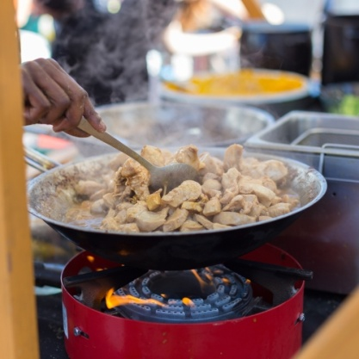
Grocer:
A small neighbourhood shop selling basic food items, both fresh and packaged (like tins of food and chocolates). Guests do not consume their food on site.
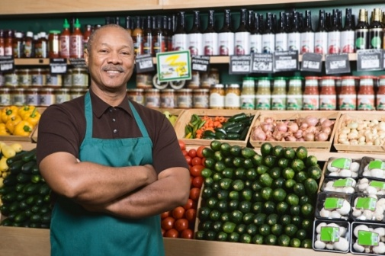
Super-markets:
A large shop, providing a huge selection of fresh goods as well as packaged goods. Guests do not consume their food on site.

Kiosk/canteen:
Where guests help themselves to food on display. Food is consumed on site.
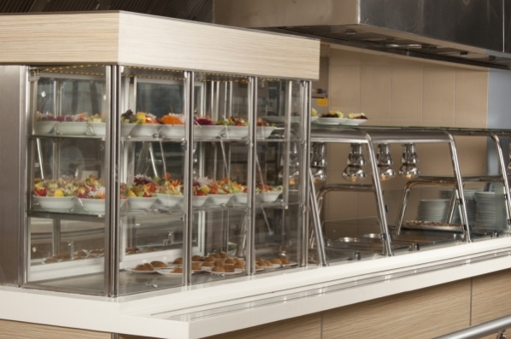
Fast Food Outlet (take-aways):
Food is already prepared, or prepared in a very short time frame. Guests do not usually consume their food on site (and if they do, it is usually with disposable cutlery and plates).
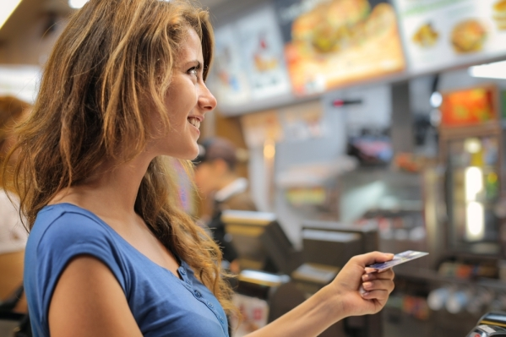
Café:
Serving snacks and light meals and non-alcoholic beverages, food is usually prepared on site.

Shebeen/Pub:
Serving snacks and light meals and beverages (predominantly alcoholic), with food usually prepared and consumed on site.

Family Restaurants:
Serving beverages and mid level meals prepared and consumed on site.
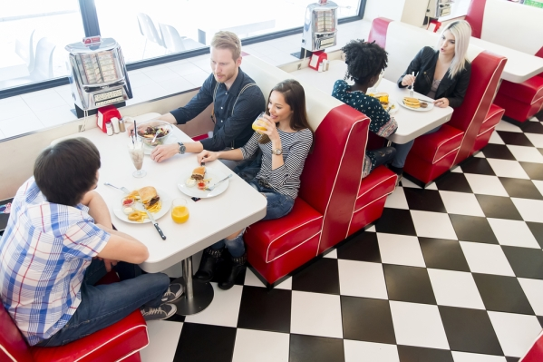
Fine Dining:
Serving a very high standard of beverages and formal meals that are prepared and consumed on site.
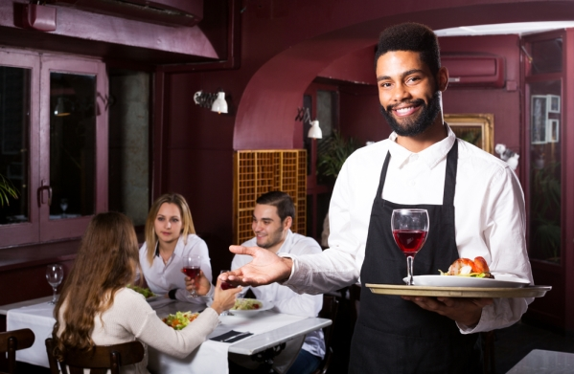
Event Caterers (outside caterers):
Providing food and beverage services for private or business functions. While food is consumed on site, it is not usually prepared there.
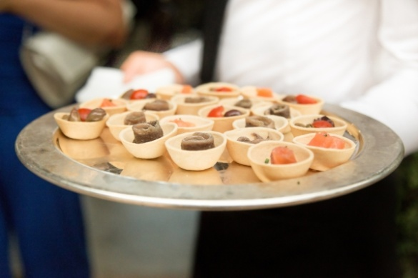
In-house Caterers:
Providing ongoing catering services for and within the same organisation, usually set up as a canteen or on-premise restaurant. Food is both prepared and consumed on site.
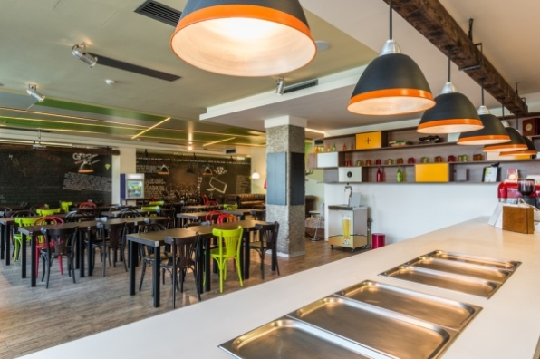
Industrial Caterers:
Providing catering services for a separate organisation on an ongoing basis. Food is prepared and generally consumed on site. Limited to good service from serving staff.

Accommodation Sector.
All establishments and services used by people who are staying away from their usual homes fall within the Accommodation sector. This sector contributes significantly to that of the Food and Beverages sector and the Hospitality industry in general.
A grading system based on 5 stars is used to rank each establishment regarding the number of facilities (from basic accommodation and bedding, to prepared meals, room-service and on-site entertainment facilities) and quality of service they provide.
The level of service provided at each establishment also varies from self-catering (i.e. no service) to all-inclusive (where a full range of services is included).
Accommodation.
Self Catering:
Includes apartments, flats, chalets or houses that can be rented out for the accommodation alone. They are usually stocked with basic equipment for guests to prepare food for themselves.
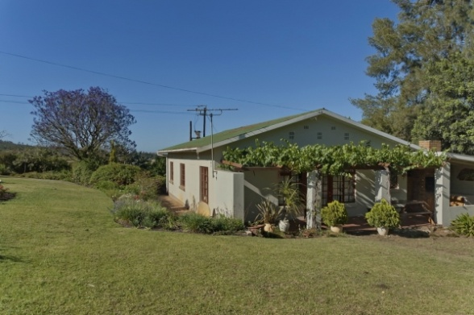
Hostels and backpackers:
Offer cheap accommodation, usually in dormitories. Some hostels provide self-catering facilities.
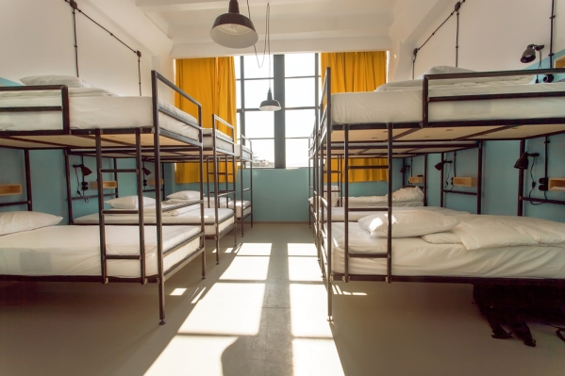
B&B & Guest Houses:
“Bed and Breakfasts” provide guests with a room to stay in and a breakfast to wake up to. Guest houses offer the same as well as access to more facilities (like swimming pools, braai areas, etc). In both instances, hosts usually stay in the same house.

Hotels:
Offer rooms (and suites) with private bathrooms, along with additional services and access to facilities. Hotels range from informal and cheap to more formal (with more services and amenities) and expensive.
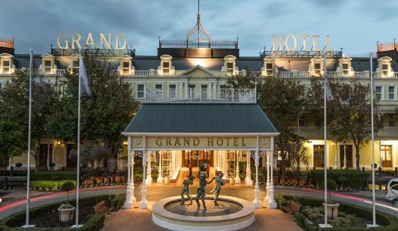
Boutique Hotels:
A much smaller, and more stylish type of hotel (between 3 and 50 rooms), sometimes providing bespoke services for guests. Most boutique hotels are more expensive than chain hotels.

Resorts and Lodges:
Usually located on a big piece of land, and inclusive of access to additional entertainment facilities (e.g. casino, game viewing, etc). Resorts can also vary in terms of the quality of services and amenities provided, from basic to luxury.

Cultural Villages:
Provide a chance to experience different ethnicities and their customs as preserved communities. Often offered as a package to tourists and other guests, and inclusive of traditional meals and live entertainment.
