

Brought to you by: | In partnership with:
 | 

TEACHERS AND LEARNERS PLEASE NOTE:



This offline non-interactive content won't allow you to analyze your own learning (vs. the wider community), assess yourself interactively, draw reports from the work you do offline or participate in a wider community which gives you access to more resources, forums and specialist knowledge.

We strongly recommend you visit: http://bit.ly/sunhospitalityoffline to learn more or scan the QR code (quick response code - the 2D bar code above) from your smartphone.

If you have questions or suggestions specifically related to this content, please email: info@obami.com

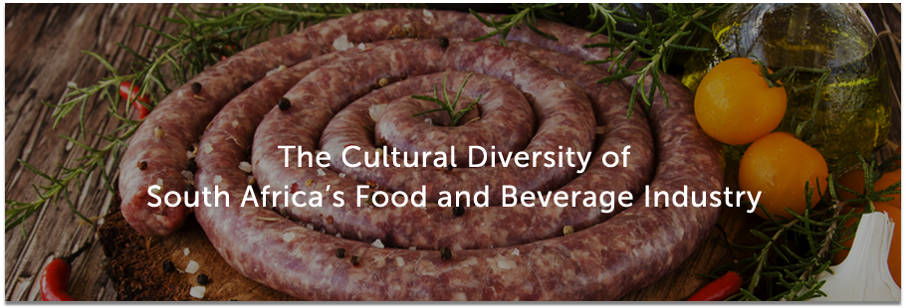
G10T1W2
South Africa is known for its extreme diversity – a cultural mixing pot at the bottom of the African continent
The country’s food and beverage industry is no different and includes traditional food, passed down through generations of indigenous people, to meals influenced by a history of colonisation and immigration, along with more westernized dishes that we find in modern day cuisine.
Indigenous Food
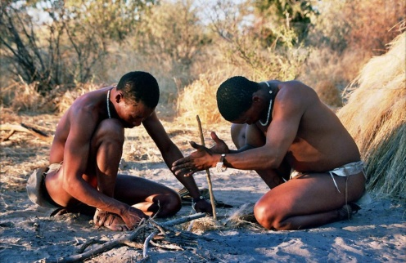
Indigenous food dates back to the ancestors of 10,000 years ago and what they could cultivate from the land and livestock. Grains, like maize and sorghum, would be cooked or fermented (and served as “pap” and “ting”), while meat from chickens, sheep and cattle would be roasted (what South Africans commonly refer to as braai-ing) or dried and preserved (what South Africans commonly refer to as biltong).
Traditional beer has played a significant role in indigenous culture for centuries. Offered at special occasions (like weddings and funerals), these home-made tonics brewed from fermented grains, were some of the very first tokens of South African hospitality. With the onset of the mining industry, traditional beer became more commercial, being sold – even to this day - from the many shebeens that have popped up across the country.
Colonisation influence on food
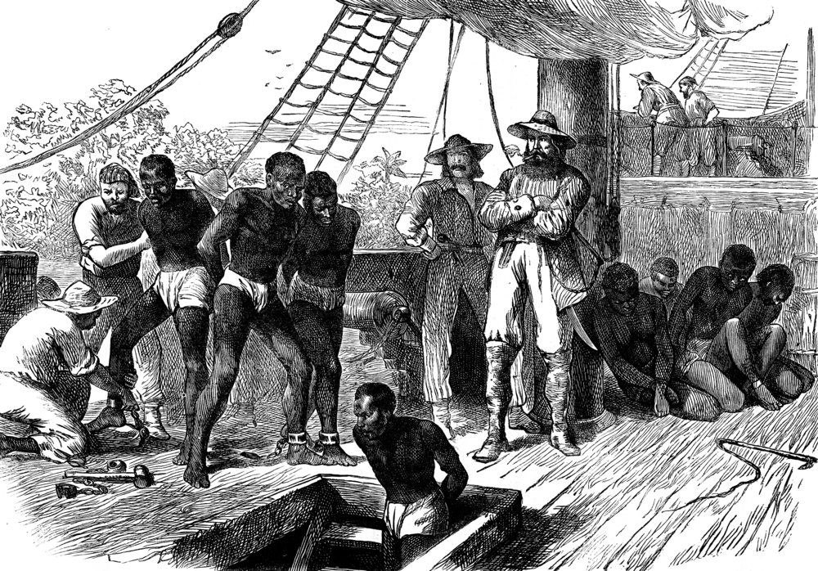
Cape Dutch cuisine was brought to South Africa by the Dutch East Company which set up a base in the Cape on the spice route between the East and Europe. Influence of Malaysian and Bengalese culture, from the slaves that were brought over at the time, is evident in the spicy dishes (like curries, pickled fish and bobotie) that South Africans are so fond of today.
South Africa’s Indian slave trade in the 19th Century also left a big impression on the country’s diverse range of foods. Curries, samoosas and bunny chow are just some dishes that have emerged from Durban’s large Indian community, and are being increasingly adopted as house-hold favourites across the country.
As the Europeans (Dutch and French) arrived in the Cape, they brought with them the practice of winemaking – the cultivating of grapes in vineyards to produce wine. The first bottle was produced in 1659 and South Africa has been known for its prestigious wine industry ever since.
Global influence on food

South Africa’s fast food and diner sectors have been largely westernised in the past few decades. It is not uncommon to find global brands (such as McDonalds, KFC and Wimpy) in cities and towns across the country. However, a number of locally started chains have been just as successful with the fast food model. Steers, Chicken Licken and Debonairs are amongst some of South Africa’s most popular fast-food chains, while Nandos has reached global popularity.
Career opportunities in the hospitality industry
Front office (customer facing)

All those jobs within the industry that require interacting with customers during their booking in process and stay.
Host/ess | Someone who receives and welcomes guests
Concierge | Someone who assists hotel guests with small tasks like recommending nearby restaurants or calling a taxi on their behalf
Receptionist | Someone who handles the administrative work to check people in and out of their accommodation, or answer calls that have been directed to the establishment (this can also be handled by a switchboard operator or a communications manager)
Porter | Someone who carries guests' luggage from the reception to the guest’s room, sometimes with the assistance of a porter trolley
Valet | Someone who parks guests' cars on their behalf

Food Service

All jobs that involve serving food to guests.
Maître d'hôtel | Someone who heads up the service in a restaurant
Waiter | Someone who takes orders from and serves food to guests
Busser (Runner) | Someone who assists the serving staff by setting and clearing tables and running other small jobs
Beverage Service
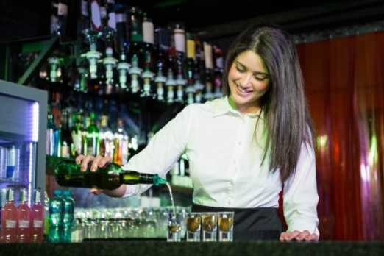
All jobs within the industry that require the serving of drinks to guests.
Barista | Someone who is in charge of making and serving coffee
Bartender | Someone who takes orders from and serves drinks to guests
Sommelier | Someone who advises on wine selection and serves wine

Food Prep

All jobs within the industry that require the preparation and cooking of food.
Executive chef | Someone who is highly specialised and in charge of food preparation and cooking for an entire kitchen
Sous chef | Someone who assists the executive chef in preparing and cooking food
Partie chef | Someone who is specialised and in charge of food preparation and cooking at one station within a kitchen

Management

All jobs that are responsible for overseeing the operations carried out by hotel staff.
Hotel managers | Someone who is responsible for the overall running of an establishment – from managing all staff and personnel, to ensuring that the hotel is kept clean and hygienic and conforms to legal requirements
Assistant hotel managers | Someone who acts as second-in-command with regards to managing the overall running of an establishment – they are able to step in for the hotel manager as and when needed
Room division managers | Someone who is responsible for the day-to-day functioning of the front office (i.e. overseeing guest satisfaction by ensuring that house-keeping, concierge and reception are all doing their jobs properly)

Behind the Scenes

All jobs within the industry that are responsible for tidying, washing and cleaning.
House-keepers | Someone who sees to the overall cleanliness and order of the establishment
Room attendant | Someone who is responsible for keeping the rooms clean (e.g. vacuuming and dusting, making beds, cleaning bathrooms) and the amenities stocked up (e.g. topping up soap and shampoo dispensers, replacing tea and coffee stock)
Public attendant | Someone who is tasked with keeping the common areas within an establishment (like the foyer, the games room, bar and dining room) clean and tidy
Laundry service operators | Someone who oversees the washing of linen and other textiles
Dishwashers | Someone who operates the dishwashing machine, making sure that it is properly packed and unpacked

Facilities Operations

All jobs that play a part in setting up and looking after an establishment's buildings and facilities.
Interior designers | Someone who is responsible for the visual aesthetic of the establishment
Electricians | Someone who ensures that electricity within the building is working and is safe for all staff and guests
Plumbers | Someone who attends to issues regarding the water supply of an establishment
Maintenance | Someone who oversees the general maintenance of the building infrastructure, and its fixtures and fittings
Security | Someone who is employed to ensure that a building is appropriately protected in terms of the security systems put in place

Business Operations

This includes all jobs (and associated departments) that assist with the running of the business.
HR | A department that is responsible for recruiting, training and managing staff
Marketing | A department that is in charge with branding and external communications
Financial | A department that looks after the financial operations of the business
IT | A department that is responsible for ensuring that the correct ICT systems are in place and are working effectively
Administration | A set of people who assist other staff members in helping them to operate the business smoothly

Franchise introduction
A franchise is a type of business model that grants people or organisations the right to operate a commercial venture under an existing brand name.
A franchisee will pay a franchisor a set up fee and an ongoing annual or monthly license fee in order to trade products and services using the business’ name. The fee paid is exchanged for access to things like proprietary knowledge, trade secrets and general processes regarding the marketing and operations of the business.
Franchises can be expensive but are often profitable for franchisees, who benefit from major cost savings in getting the business to market (through proven processes and centralised operations).
However, franchisees are not entitled to claim any ownership rights in the business and cannot customise the services and product that they offer to their customers. Specifications with regards to branding, trading hours and pricing are all decided and enforced (through complex legal contracts) by the franchisor.

