QMS
Quality Management System

2023
Teacher [PL1]

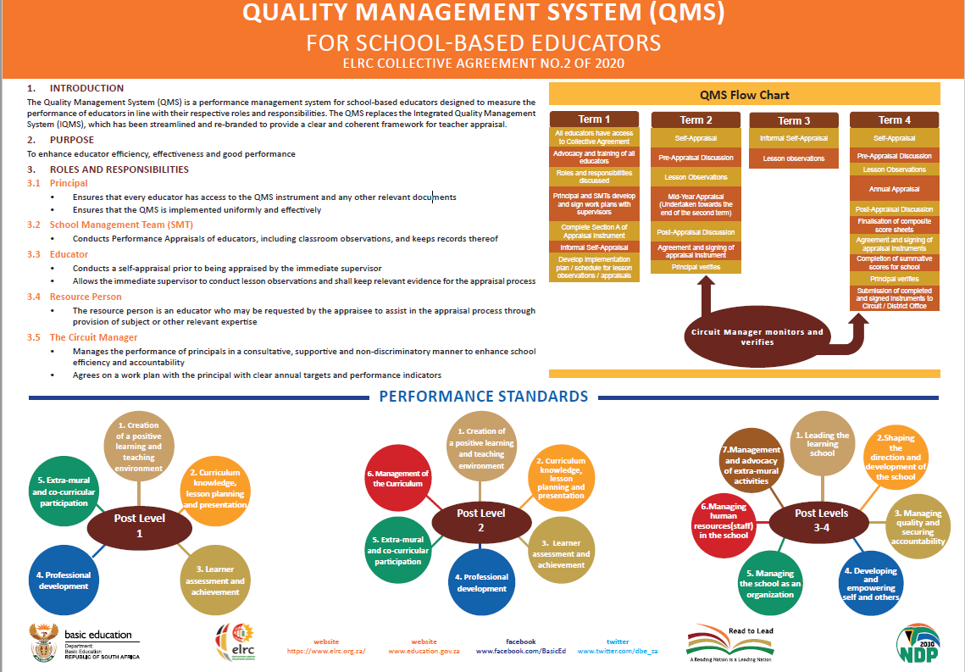

Work Plan

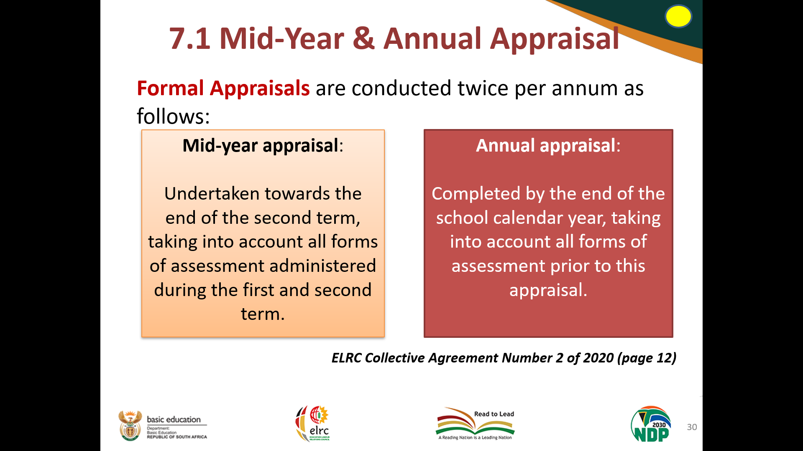
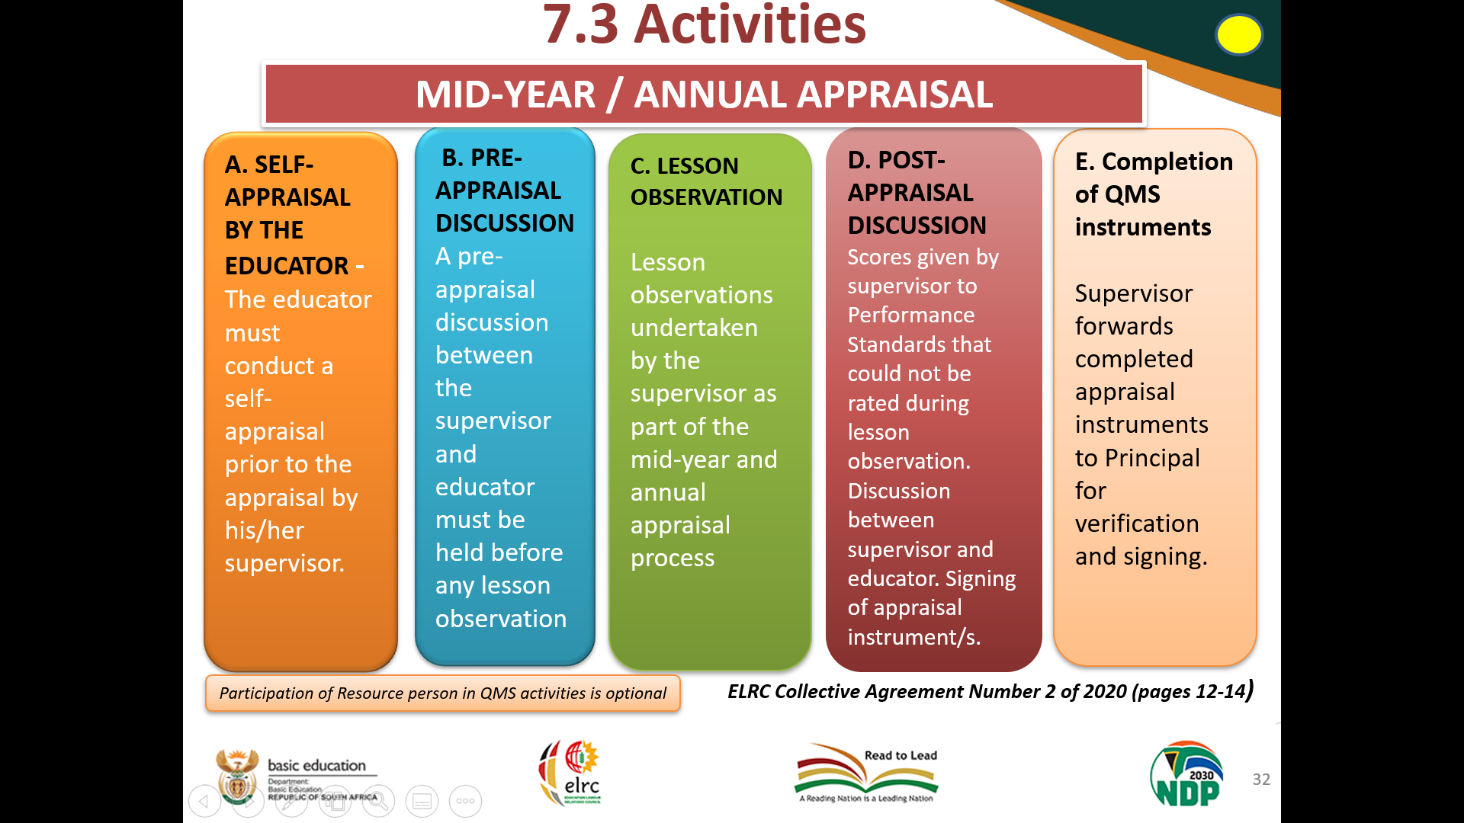
Mid-year
Appraisal

INDEX
- Self-Appraisal Instrument
- Pre-Appraisal Discussion
- Lesson Observation
- Mid-year Appraisal
- Post-Appraisal Discussion

Minutes of
Pre-Appraisal Discussion

held on 1 March 2023 at

Hoërskool Bergvlam at 14:00

Welcoming:
Appraiser welcomed the appraisee/s.

Attendance register:
_________________________________ (Departmental Head)
_________________________________
_________________________________
_________________________________
_________________________________
_________________________________

Points of discussion:
- Class visit schedule (attached)
- Expectations according to the appraisal instrument
- Self-appraisal instrument: weaknesses and strengths
- Please note that a post-appraisal discussion will follow the class visit (lesson observation) and completed appraisal instrument by the appraiser

Closing:
Next meeting – a post-appraisal discussion
Meeting adjourned

CLASS VISIT
LESSON OBSERVATION
Subject/s: Afrikaans & Geography/Social Sciences

DEPARTMENTAL HEAD (DH): Louise Fullard

SUBJECT HEAD/S: Riette Nel & Simone de Jager

YEAR: 2023
EDUCATOR | VISITED BY | CAPACITY | WEEK | TERM 1/2 | TERM 3/4
R Nel | L Fullard | DH | 4 | FEB/MARCH | AUG/SEP
S De Jager | L Fullard | DH | 4 | FEB/MARCH | AUG/SEP
E Van Zyl | L Fullard | DH | 5 | FEB/MARCH | AUG/SEP
D Eksteen | L Fullard | DH | 5 | FEB/MARCH | AUG/SEP
A Boje | L Fullard | DH | 5 | FEB/MARCH | AUG/SEP
M Vermeulen | L Fullard | DH | 5 | FEB/MARCH | AUG/SEP
A Du Toit | L Fullard | DH | 6 | FEB/MARCH | AUG/SEP
L Fullard | GF VD BERG | Deputy P | 6 | FEB/MARCH | AUG/SEP

Minutes of
Post-Appraisal Discussion

held on 3 May 2023 at

Hoërskool Bergvlam at 14:00

Welcoming:
Appraiser welcomed the appraisee/s.

Attendance register:
L Fullard (Departmental Head)
_________________________________
_________________________________
_________________________________
_________________________________

Points of discussion:
- Discussion of appraisal instrument completed by the appraiser
- Opportunity for appraisee/s’ input regarding the evaluation
- Finalisation of the appraisal instrument
- Discussion of the finalisation of the composite score sheet
- Discussion of the filing and verification of the final appraisal instrument and composite score sheet

Closing:
Next meeting – a pre-appraisal discussion
Meeting adjourned

Annual
Appraisal

INDEX
- Self-Appraisal Instrument
- Pre-Appraisal Discussion
- Lesson Observation
- Annual Appraisal
- Post-Appraisal Discussion
- Composite Score Sheet

Minutes of
Pre-Appraisal Discussion

held on 1 Augustus 2023 at

Hoërskool Bergvlam at 14:00

Welcoming:
Appraiser welcomed appraisee/s.

Attendance register:
_________________________________ (Departmental Head)
_________________________________
_________________________________
_________________________________
_________________________________
_________________________________

Points of discussion:
- Class visit schedule (attached)
- Expectations according to the appraisal instrument
- Self-appraisal instrument: weaknesses and strengths
- Please note that a post-appraisal discussion will follow the class visit (lesson observation) and completed appraisal instrument by the appraiser

Closing:
Next meeting – a post-appraisal discussion
Meeting adjourned
Minutes of
Post-Appraisal Discussion

held on 16 October 2023 at

Hoërskool Bergvlam at 14:00

Welcoming:
Appraiser welcomed appraisee/s.

Attendance register:
L Fullard (Departmental Head)
_________________________________
_________________________________
_________________________________
_________________________________

Points of discussion:
- Discussion of appraisal instrument completed by the appraiser
- Opportunity for appraisee/s’ input regarding the evaluation
- Finalisation of the appraisal instrument
- Discussion of the finalisation of the composite score sheet
- Discussion of the filing and verification of the final appraisal instrument and composite score sheet

Closing:
Meeting adjourned

Summative
Scores
[E1]

Reports

