**QMS_ONLINE RESOURCE FOR THE DEVELOPMENT OF A WORK PLAN**

QMS - ONLINE RESOURCE FOR THE DEVELOPMENT OF A WORK PLAN FOR PRINCIPALS.

<https://rise.articulate.com/share/epwSDG4FvaziT_p_poRFj5_i4dUry8Uu>

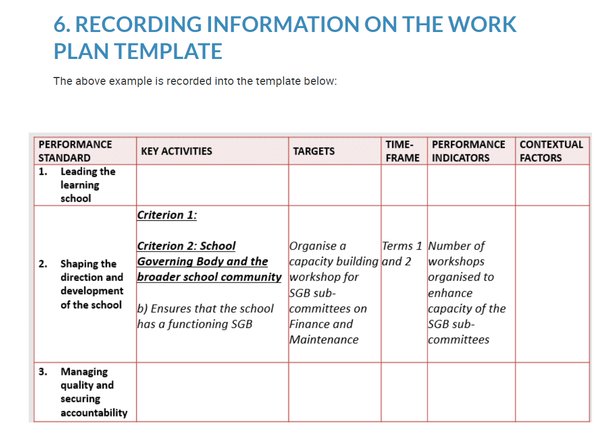

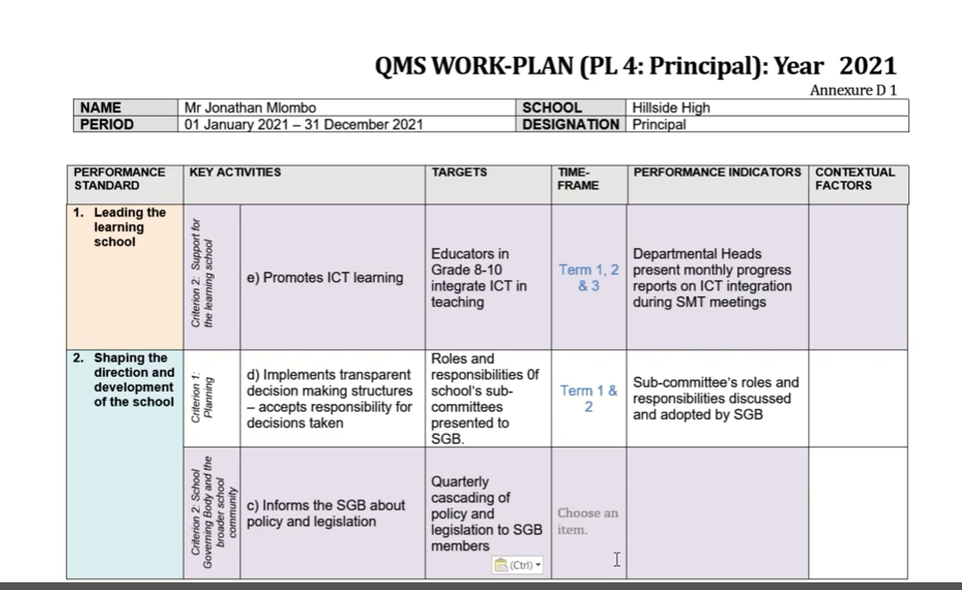

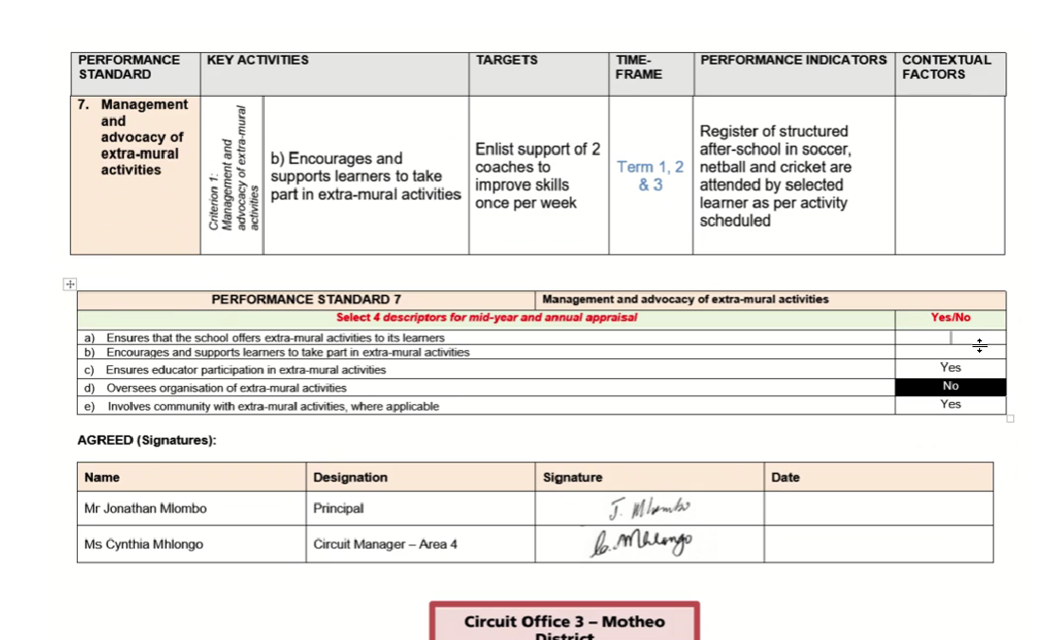

QMS - ONLINE RESOURCE FOR THE DEVELOPMENT OF A WORK PLAN FOR DEPUTY PRINCIPALS

<https://rise.articulate.com/share/pLcbzNVyB8G2GRHwgL45V5mwWV_rg7Y5>

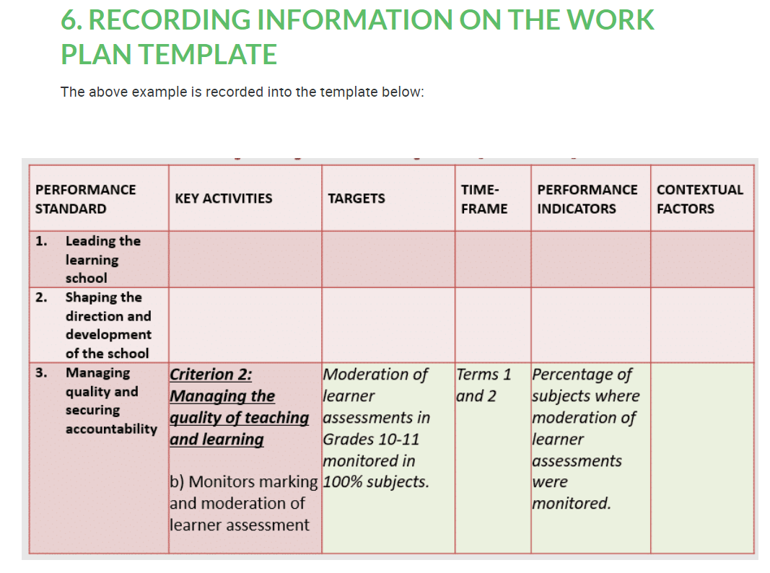

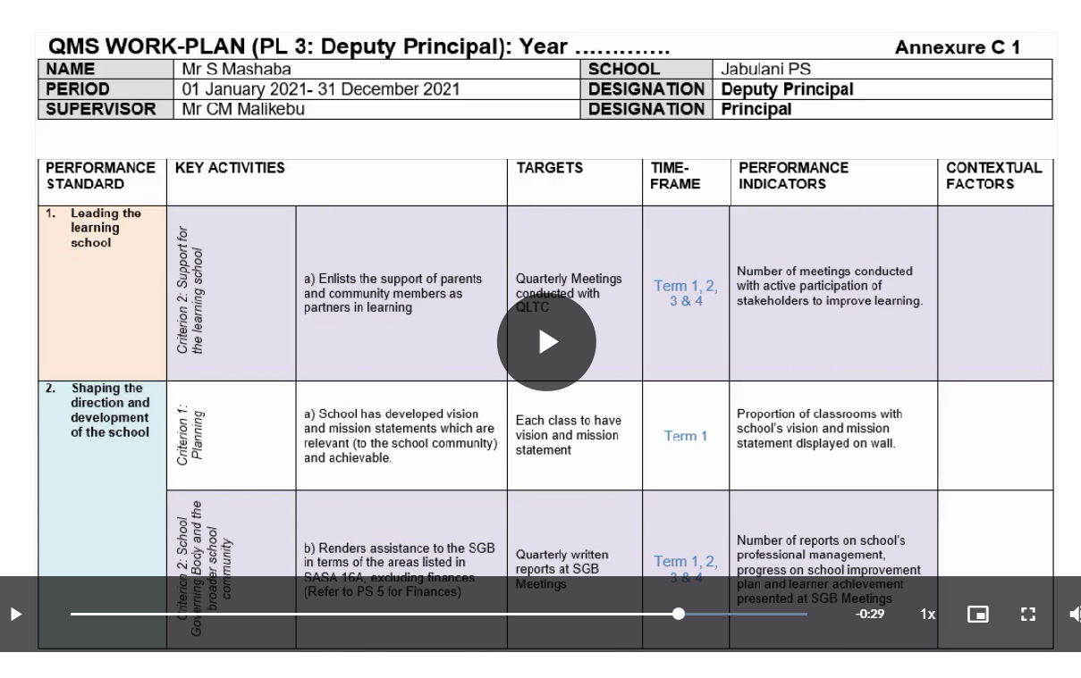

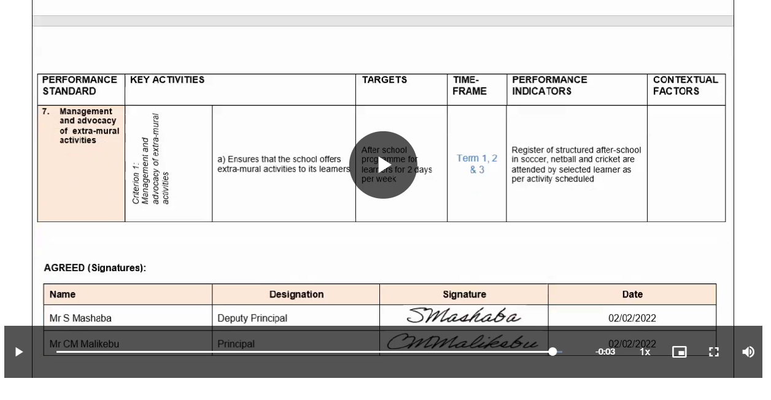

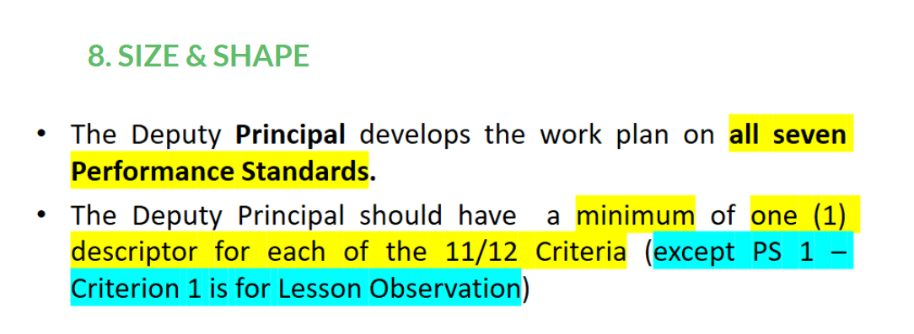

QMS - ONLINE RESOURCE FOR THE DEVELOPMENT OF WORK PLANS FOR DEPARTMENTAL HEADS

<https://rise.articulate.com/share/mrd01UXfHUcuzKKMMnuKyt86XLhqBXsU>

