HARVEST FOOD FESTIVAL

A FEAST FOR THE SENSES

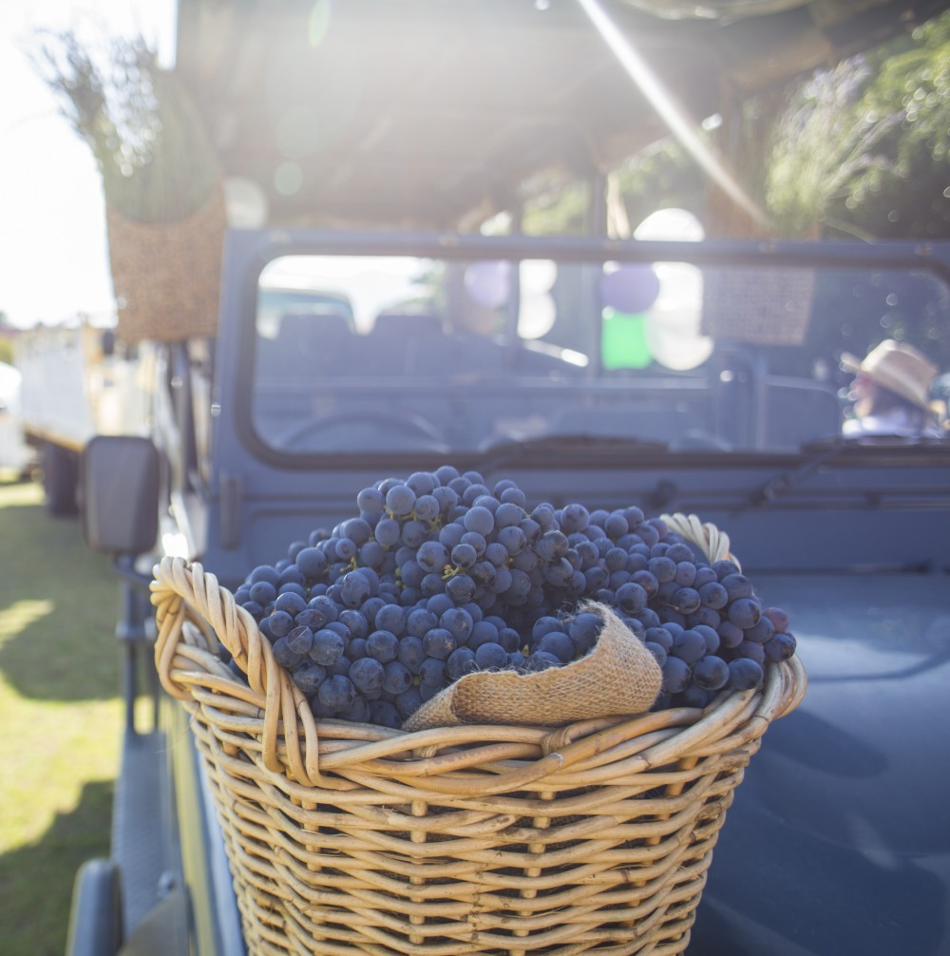

|  |  |
| --- | --- |
| Date | 24 to 26 November 2017 |
| Venue | Coetzenburg Sports Ground |