|  |  |
| --- | --- |
| SA top Artists  https://theculturetrip.com/africa/southafrica/articles/ southafricas10youngartistsandwheretofindthem/ | Insert author  Abstract  [Abstract] |

**TABLE OF CONTENTS**

Our artists 2

Jane Alexander 2

Walter Battiss 2

Marlene Dumas 2

Jackson Hlungwani 3

William Kentridge 3

Noria Mabasa 3

Bonnie Ntshalintshali 3

George Pemba 4

Pierneef 4

Gerard Sekoto 4

Durant Sihlali 5

Cecil Skotnes 5

Irma Stern 5

Tretchikoff 5

Sue Williamson 5

Explore our Art Galleries 6

Photo Credits 7

**15 OF SOUTH AFRICA'S MOST FAMOUS VISUAL ARTISTS**

Although it is impossible to come up with a finite list, here are 15 of some of South Africa's most internationally famous visual artists (in no particular order).

# Our artists

## Jane Alexander

Born in 1959 in Johannesburg, Alexander claimed the limelight, whilst still a student. Her piece The Butcher Boys (three life-size sculptures of strangely deformed men with animal horns) is well-known. Since then the highly regarded artist has produced Bom boys and Lucky Girls (her interpretations of street children from Long Street, Cape Town). She lectures at Michaelis School of Fine Art.

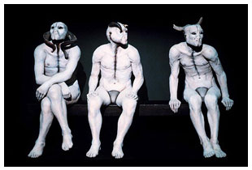

Figure 1: Butcher Boys by Jane Alexander

## 

## Walter Battiss

Born in the Karoo (1906 – 1982). He is considered South Africa's heavyweight abstract painter and creator of the 'Fook Island' concept. He was heavily influenced by the archaeology and rock art of his youth in Koffiefontein. People respond to his works' joie de vivre, appreciation of beauty, and sensual presentation of the human body.

## Marlene Dumas

Born in 1953, Dumas grew up on her father's winery in Kuilsrivier. She lives and works in Amsterdam where she is regarded as one of the most influential painters today. She is known for her thought-provoking subject matter, and her unique approach to the way she uses the canvas. She merges political discourse, personal experience and art historical references.

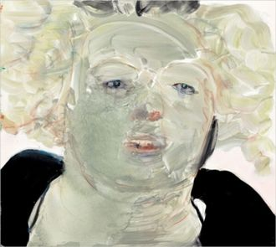

Figure 2: Marlene Dumas Self Portrait

## Jackson Hlungwani

(1923 – 2010) He was born to a Shangaan migrant worker who taught him to carve household objects. Hlungwani began carving fulltime after his career as a miner came to an end when he lost a finger. He lived in a village near Elim and is one of the most critically acclaimed South African artists, best known for his carvings of fish.

## William Kentridge

Born in 1955, Kentridge is ranked as the ninth most significant modern contemporary artist in the world. He is known for his prints, drawings and stop motion animated films, shadow plays, mechanical puppets, sculptures, and live performance pieces. He is most famous for using only charcoal, with a touch of red or blue pastel, to create near-expressionist works.

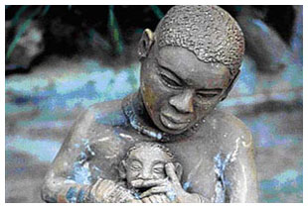

## Noria Mabasa

Born in1938, Mabasa is a Venda artist best known for her ceramic and wood works. She is completely self-taught and a full-time artist since 1976. Much of her work is dream-inspired. Her ceramic figures painted with enamel won her both national and international acclaim during the 1980s.

## Bonnie Ntshalintshali

(1967 – 1999) She one of the original Ardmore Studio's young ceramicists and Ntshalintshali had no art background or training. Because of her childhood polio she was instead taken on as a student by Fee Halsted, the owner of the farm. They went on to jointly win the 1990 Standard Bank Young Artist Award. It was difficult to separate their work as they relied heavily on one another's creative influences, despite their very different styles.

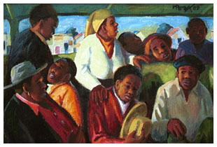

## George Pemba

(1912 – 2001) With no formal training and huge financial responsibilities for family, Pemba was not able to obtain formal art training, or become the full-time artist he desired to be, despite his obvious talent. In the 1980s, late in his career, things changed and he began to receive recognition for his work. Commercial success followed. Pemba dreamed that art would promote healing and tolerance in Africa.

## Pierneef

(1886 – 1957) He was a landscape artist who is considered one of the old South African masters. He had a very definite style that reduced the landscape to a series of geometric structures, using flat planes, colour and lines. He believed that South African artists should have their own style and set of rules to follow, divorced from the English system on which art education was based.

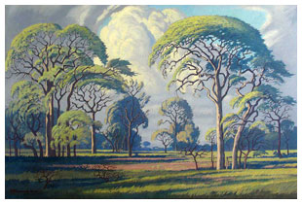

## Gerard Sekoto

(1913 – 1993) Sekoto was both an artist and a musician. His exhibitions were not only local, but took him to Paris, Stockholm, Venice, Washington and Senegal. He left South Africa to live in Paris in 1947. In Paris, he was employed as a pianist, which paid for his art school expenses. He finally received the recognition he deserved in his home country in 1989. He was given a retrospective exhibition in Johannesburg, and an honorary doctorate.

## Durant Sihlali

(1935 – 2004) He worked across many media – painting, sculpture, printmaking and pulp paintings. He was branded during the 1970s as a 'township artist' and his work documented historical realities. He went abroad during the 1980s where he produced a huge body of work.

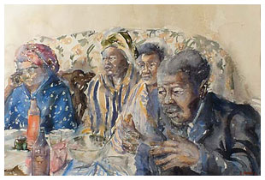

## Cecil Skotnes

(1926 – 2009) He was regarded as a pioneer of African Abstraction. He contributed greatly to the development of black artists. His work is distinctive with bold colours and spiritual overtones, but his trademark medium was painted wood panels.

## Irma Stern

(1894 – 1966) Stern travelled extensively in her lifetime and painted the landscape and people she met on her travels in a vivid and energetic style. She was to become famous both nationally and internationally in her lifetime, and her home in Rosebank, Cape Town is today a museum dedicated to her work.

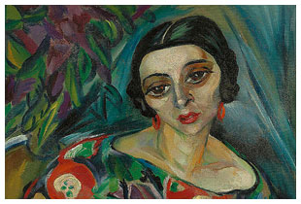

Figure 3: Irma Stern

## Tretchikoff

1913 – 2006 – not really regarded as a 'South African artist', Vladmir Tretchikoff was one of the most commercially successful artists of his time and became popular not only in South Africa but internationally as well. He was to live in South Africa from 1946, and his famous Chinese Girl is one of the bestselling prints of the twentieth century.

## Sue Williamson

Born in 1941 Williamson immigrated to South Africa in 1948. Regarded as an activist artist she became famous for her photographic portrait prints featuring women in the struggle against apartheid – A Few South Africans. She has produced works on the Truth and Reconciliation Commission, HIV/AIDS and more recently a multimedia celebration of the women who helped usher in South Africa's liberation, entitled All Our Mothers.

# Explore our Art Galleries

| **Province** | **Gallery Name** | **Location** |
| --- | --- | --- |
| Eastern Cape Art Galleries | GFI Art Gallery | Central |
| Eastern Cape Art Galleries | Anne Bryant Art Gallery | East London |
| Eastern Cape Art Galleries | Hester Rupert Art Museum | Graaf Reinett |
| Eastern Cape Art Galleries | Starways Pottery & Gallery | Hogsback |
| Eastern Cape Art Galleries | Nieu Bethesda Art Centre | Nieu Bethesda |
| Eastern Cape Art Galleries | King George VI Art Gallery | Port Elizabeth |
| Eastern Cape Art Galleries | Ruth Lock Shell Art Gallery | Queenstown |
| Eastern Cape Art Galleries | Café Ruwach Art & Craft Gallery | Richmond Hill |
| Eastern Cape Art Galleries | Bitou Art Gallery | Storms River |
| Gauteng Art Galleries | Afrinova | Braamfontein |
| Gauteng Art Galleries | Wits Art Museum | Braamfontein |
| Gauteng Art Galleries | Anton Smit Sculpture Park | Bronkhorstspruit |
| Gauteng Art Galleries | Mabokeng Art on main | Johannesburg |
| Gauteng Art Galleries | In Toto Gallery | Melrose |
| Gauteng Art Galleries | Thomson Gallery | Melville |
| Gauteng Art Galleries | Thompson Gallery | Melville |
| Gauteng Art Galleries | Afronova Art Gallery | Newtown |
| Gauteng Art Galleries | Gallery Momo | Parktown |
| Gauteng Art Galleries | Gallery 2 | Parkwood |
| Gauteng Art Galleries | Goodman Gallery | Parkwoord |
| Gauteng Art Galleries | Chris Tugwell Art Gallery | Pretoria |
| Gauteng Art Galleries | The Pierneef House Museum | Pretoria CBD |
| Gauteng Art Galleries | Circa on Jellicoe | Rosebank |
| Gauteng Art Galleries | Art Afrique Gallery | Sandton |
| Gauteng Art Galleries | Everard Read Gallery | Sandton |
| KwaZulu-Natal Art Galleries | Imbizo Gallery | Ballito |
| KwaZulu-Natal Art Galleries | Ardmore Ceramic Art Studio | Champagne Valley |
| KwaZulu-Natal Art Galleries | Absorb & Acquire African Art | Durban |
| KwaZulu-Natal Art Galleries | Touch of Mandela Art Gallery | Durban |
| KwaZulu-Natal Art Galleries | Durban Art Gallery | Durban |
| KwaZulu-Natal Art Galleries | Old Court House Museum | Durban Central |
| KwaZulu-Natal Art Galleries | Empangeni Museum | Empangeni |
| KwaZulu-Natal Art Galleries | KwaZulu-Natal Society of Arts | Glenwood |
| KwaZulu-Natal Art Galleries | Campbell Collections | Greyville |
| KwaZulu-Natal Art Galleries | Underberg Studio | Himeville |
| KwaZulu-Natal Art Galleries | Fat Tuesday Gallery | Kloof |
| KwaZulu-Natal Art Galleries | Margate Art Museum | Margate |
| KwaZulu-Natal Art Galleries | Graceville Gallery | Mooi River |
| KwaZulu-Natal Art Galleries | Blue Caterpillar Art Gallery | Pietermaritzburg |
| Western Cape Art Galleries | Magpie Art Collective Gallery | Barrydale |
| Western Cape Art Galleries | Irma Stern Museum | Cape Town |
| Western Cape Art Galleries | Cape Town Gallery | Cape Town Central |
| Western Cape Art Galleries | Artefundo Art Gallery | Franchhoek |
| Western Cape Art Galleries | Star Nation Art Studios & Gallery | Heidelberg |
| Western Cape Art Galleries | Walker Bay Art Gallery | Hermanus |
| Western Cape Art Galleries | Mossel Bay Craftm Art | Mossel Bay |
| Western Cape Art Galleries | Riek Creative Art Gallery | Napier |
| Western Cape Art Galleries | Stone Fish Studio and Gallery | Paternoster |
| Western Cape Art Galleries | Chadoka Art Studio | Pringle Bay |
| Western Cape Art Galleries | Stellenbosch Art Gallery | Stellenbosch |
| Western Cape Art Galleries | Kunstehuijs Fine Art Gallery | Swellendam |

# Most famous works

|  |  |
| --- | --- |
| Artist | Famous work |
| Jane Alexander | Bom boys and Lucky Girls |
| Walter Battiss | Fook Island |
| Marlene Dumas |  |
| Jackson Hlungwani |  |
| William Kentridge |  |
| Noria Mabasa |  |
| Bonnie Ntshalintshali |  |
| Tretchikoff | Chinese Girl |
| Insert formula |  |

# Photo credits

Butcher Boys by Jane Alexander Photo © Artthrob

Marlene Dumas – Self Portrait

By Noria Mabasa Photo © Artthrob

By George Pemba

Hardkoolbome Bosveld by Pierneef

By Durant Sihlali Photo © Artthrob

By Irma Stern (Insert cross reference here)