Blocos are groups of individuals who plan street parties during the Carnival in Rio de Janeiro. Their parties are much more casual than the parades in the Sambadrome. Each Bloco writes a theme song and has a band to play the Samba music. These groups gather in their local hangouts and play percussion music well into the early hours of the morning. Many of these Blocos have official T-shirts that anyone can purchase while at the Rio Carnival. The Blocos are considered the heart and soul of the Rio Carnival - there are Blocos popular with singles and others that hold parties suitable for families.



1. **Individual Blocos**

The largest Bloco is Cordao do Bola Preta and over 200,000 people will attend their street party. Simpatia e Quase Amor draws about 100,000 people to its celebration. Monobloco holds their party on and up to 80,000 revelers attend this Carnival party. These larger parties are held on Avenida Rio Branco, one of the largest streets in Rio and there is no other place that can accommodate such large parties. Spectators are invited to join in or, if they prefer, to watch from the stands that line the avenue.

1. 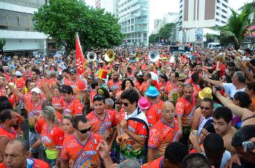**Banda de Ipanema**

Banda de Ipanema holds three different street parties. These parties are very popular with the gay crowd. This Bloco starts the Rio Carnival by drawing up to 30,000 people during its first two parties held the Saturdays just before the Carnival. They have a 3rd party the Saturday of the Carnival week.

1. **Suvaco do Cristo**

The Suvaco do Cristo Bloco holds their parade in the Jardim Botanico district. They were formed in 1985 by a group of friends. Every year they have their own Samba-enredo, a percussion section, a flag and flag bearer and a group of women who dress in Bahia clothing. Their colors are sliver, blue and green. They typically hold their parade the Sunday before the Carnival begins.

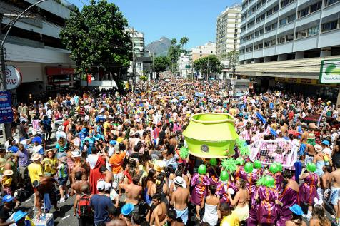

1. **Monobloco**

Monobloco (ref) has the honour of closing the Carnival. In 2009 there were 400,000 people that joined the 200 strong Monobloco band. Monobloco began in 2003 parading on Leblon beach. The band has 200 musicians and they play samba, coco, xote, congo, and even Brazilian square dance and quadrilha music. Locals even enjoy attending their rehearsals in Lapa. This Bloco is very popular with young people.

5. Individual Blocos

The largest Bloco is Cordao do Bola Preta and over 200,000 people will attend their street party. Simpatia e Quase Amor draws about 100,000 people to its celebration. Monobloco holds their party on and up to 80,000 revelers attend this Carnival party. These larger parties are held on Avenida Rio Branco, one of the largest streets in Rio and there is no other place that can accommodate such large parties. Spectators are invited to join in or, if they prefer, to watch from the stands that line the avenue.

6. Banda de Ipanema

Banda de Ipanema holds three different street parties. These parties are very popular with the gay crowd. This Bloco starts the Rio Carnival by drawing up to 30,000 people during its first two parties held the Saturdays just before the Carnival. They have a 3rd party the Saturday of the Carnival week.

7. Suvaco do Cristo

The Suvaco do Cristo Bloco holds their parade in the Jardim Botanico district. They were formed in 1985 by a group of friends. Every year they have their own Samba-enredo, a percussion section, a flag and flag bearer and a group of women who dress in Bahia clothing. Their colors are sliver, blue and green. They typically hold their parade the Sunday before the Carnival begins.

8. Monobloco

Monobloco (ref) has the honour of closing the Carnival. In 2009 there were 400,000 people that joined the 200 strong Monobloco band. Monobloco began in 2003 parading on Leblon beach. The band has 200 musicians and they play samba, coco, xote, congo, and even

Brazilian square dance and quadrilha music. Locals even enjoy attending their rehearsals in Lapa. This Bloco is very popular with young people.