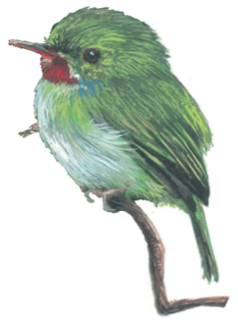**Global Warming**

*Birds in a Changing Climate* Adjusted from: www.scscb.org

**What is Global Warming?**

E

very time we drive a car, use electricity from coal-fired power plants, or cool or heat our homes with oil or natural gas, we release carbon dioxide (CO2) and other heat-trapping gases to the atmosphere. These gases act like a blanket, trapping heat and warming the Earth’s surface. The more of these gases we release, the thicker the blanket becomes.

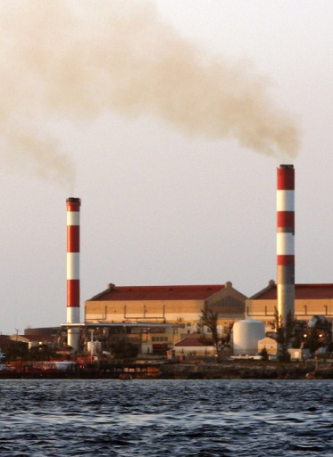

This heat-trapping blanket has warmed the Earth about 1°F during the past century. The last two decades are the warmest on record. Earth has not experienced such a rapid change in temperature in thousands of years. Unless we reduce the pollution that causes global warming, the world’s top scientists predict that temperatures could climb between 2.0° to 11.5°F this century.

**How will Global**

**Warming affect us?**

The earth’s climate is warming. Human activities such as burning fossil fuels and clearing forests are causing the warming by adding more heat-trapping gases, primarily carbon dioxide (CO2), to the atmosphere.

The heat-trapping gases blanketing the Earth are already causing changes in our climate and ecosystems:

* Glaciers and Antarctic ice sheets are melting, our oceans are warming and snow cover is decreasing worldwide.
* Globally sea level has risen 10-20 cm (4-8 inches) over the past century, putting coastal areas and millions of people at risk from erosion, flooding during storms, and permanent submersion of low-lying areas and islands.
* Winters are milder, spring is earlier and the frequency and severity of extreme weather events (storms, droughts) has increased.
* Human health is being affected as some diseases that thrive in warmer climates are spreading, and there are increased deaths and injuries from heat waves, floods, storms, fires and droughts.
* Plant and animal ranges are shifting, in response to climate change. Some birds are migrating and nesting earlier while others have stopped migrating altogether.

Climate change will affect almost every aspect of human society and the natural world. While there may be some benefits of warming, for example, longer growing seasons in temperate regions, overall, the impacts will be negative and severe. Should temperatures rise 3-5°F or so, 20-30% of plants and animals could become extinct and coasts and island inhabited by hundreds of millions of people could be flooded. Hardest hit will be the tropics and subtropics, where many of the world’s poorest people live. At the high end of the warming predictions, the world could face abrupt, catastrophic and irreversible consequences.

**Effects of Global Warming in the Caribbean**

Small islands have characteristics that make them especially vulnerable to the effects of global warming, sea level rise, and extreme events. Our beautiful beaches, coral reefs, mangroves, fisheries, bird life, and livelihoods focused on the coast are all threatened by climate change.

* **Hurricanes and storms are predicted to become more frequent and intense.** Together with rising sea level, this will worsen flooding, storm surge, and erosion of beaches, threatening vital infrastructure, settlements and facilities that support the livelihood of island communities.
* **Marine and coastal ecosystems are at risk.** Warming ocean waters threaten **corals** by causing them to “bleach” as they expel the symbiotic algae that nourish and give them color. This could lead to widespread coral reef mortality, damaging regional fisheries and tourism. Coastal mangroves and wetlands, which protect vulnerable coastlines from storm surge and flooding, are threatened by sea level rise.
* **Caribbean forests will also suffer from climate change**, especially hurricane damage and increased drought.
* **Summer drought is expected to increase**, causing water shortages in many islands. This will have an negative impact on birds.
* Widespread development for tourism has already diminished habitat for fish, birds and other wildlife. **Global warming could push some of the most endangered species to extinction.**

**What can YOU do to help reduce Global Warming?**

A

dapting to climate change is essential because we are already committed to a certain amount of warming from the greenhouse gases that are already in the atmosphere. However, we can avoid the worst impacts of global warming if we act now to slow it. Here are some ways that you can cut your global warming pollution, become more energy efficient, save money, and give something back to nature.

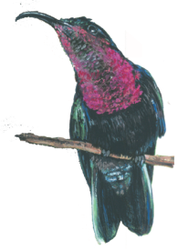**Turn off electronic devices you’re not using**

Simply turning off your television, DVD player, stereo, and computer when you’re not using them will save you thousands of pounds of CO2 a year.

**Reduce, reuse and recycle at home and at work**

You can save 2,400 pounds of CO2 a year by recycling half of the waste your household generates

**Plant a tree**

A single tree will absorb one ton of CO2 over its lifetime. Shade provided by trees can also reduce your air conditioning bill by 10 to 15%.

**Drive less**

Walk, bike, carpool or take mass transit more often. You’ll save one pound of CO2 for every mile you don’t drive.

**Choose energy efficient appliances when making new purchases**

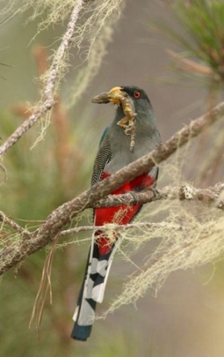

Look for the **Energy Star** label on new appliances to choose the most efficient models.

**Encourage your school or business to protect rare species**

Some of the rarest bird species are:

Snow Goose *Chen caerulescens*

Canada Goose *Branta canadensis*

Trumpeter Swan *Cygnus buccinator*

Wood Duck *Aix sponsa*

**Protect mangroves, wetlands, forests and species**

Forests and wetlands play a critical role in global warming: they store carbon. Conservation of these threatened habitats will reduce atmospheric CO2 as well as protect our birds and other species.

Figure 1: Comparison of bird species for 2000 and 2014

|  |  |  |
| --- | --- | --- |
|  | 2000 | 2014 |
| Bachman's sparrow | 1922 | 1401 |
| Bald eagle | 1121 | 1013 |
| Loggerhead shrike | 1339 | 1077 |
| Double-crested cormorant | 256 | 122 |
| Red-cockheaded woodpecker | 338 | 173 |