Pangolins

[Draw your reader in with an engaging abstract. It is typically a short summary of the document. When you’re ready to add your content, just click here and start typing.]

[Document subtitle]

Contents

Introduction 2

Description 2

Solitary animals 2

Behaviour 3

Nocturnal animals 3

Diet 4

Insectivorous 4

Reproduction 4

Mating season 4

Threats 5

# Introduction

Pangolins or scaly anteaters [1] are mammals of the order Pholidota. The one extant family, Manidae, has three genera: Manis, which comprises four species living in Asia; Phataginus, which comprises two species living in Africa; and Smutsia, which comprises two species also living in Africa [2]. These species range in size from 30 to 100 cm. A number of extinct pangolin species are also known.

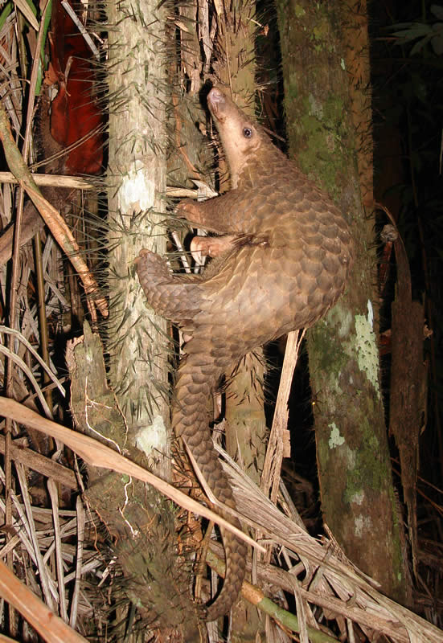

A pangolin

# Description

## Solitary animals

Pangolins have large, protective keratin scales covering their skin; they are the only known mammals with this feature. They live in hollow trees or burrows, depending on the species. Pangolins are nocturnal, and their diet consists of mainly ants and termites, which they capture using their long tongues. They tend to be solitary animals, meeting only to mate and produce a litter of one to three offspring, which are raised for about two years.

Pangolins are threatened by poaching (for their meat and scales) and heavy deforestation of their natural habitats, and are the most trafficked mammals in the world [3]. Of the eight species of pangolin, four are listed as vulnerable, two are listed as endangered, and two are listed as critically endangered on the International Union for Conservation of Nature Red List of Threatened Species [4].

The name pangolin comes from the Malay word pengguling, meaning "one who rolls up" [5]. However, the modern name in Standard Malay is tenggiling, whereas in Indonesian it is trenggiling.

The physical appearance of a pangolin is marked by large hardened overlapping plate-like scales, which are soft on new-born pangolins, but harden as the animal matures [9]. They are made of keratin, the same material from which human fingernails and tetrapod claws are made, and are structurally and compositionally very different from the scales of reptiles [10]. The pangolin's scaled body is comparable in appearance to a pine cone. It can curl up into a ball when threatened, with its overlapping scales acting as armour, while it protects its face by tucking it under its tail. The scales are sharp, providing extra defence from predators [11].

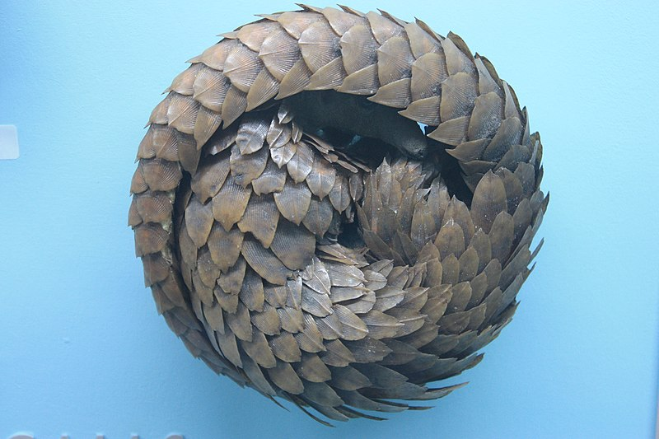

A pangolin in the defensive posture

Pangolins can emit a noxious-smelling chemical from glands near the anus, similar to the spray of a skunk [12]. They have short legs, with sharp claws which they use for burrowing into ant and termite mounds, and climbing [13].

The tongues of pangolins are extremely long, like those of the giant anteater and the tube-lipped nectar bat; the root of the tongue is not attached to their hyoid bone, but is in the thorax [14]. between the sternum and the trachea. Large pangolins can extend their tongues as much as 40 cm (400 mm; 16 in), with a diameter of only 0.5 cm (5.0 mm; 0.20 in; 200 thou) [15].

# Behaviour

## Nocturnal animals

Most pangolins are nocturnal animals that use their well-developed sense of smell to find insects. The long-tailed pangolin is also active by day, while other species of pangolins spend most of the daytime sleeping, curled up into a ball [15]. They are considered to be shy and secretive creatures [16].

Arboreal pangolins live in hollow trees, whereas the ground-dwelling species dig tunnels underground, to a depth of 3.5 m (11 ft) [15].

Some pangolins walk with their front claws bent under the foot pad, although they use the entire foot pad on their rear limbs. Furthermore, some exhibit a bipedal stance for some behaviour and may walk a few steps bipedally [17]. Pangolins are also good swimmers [15].

# Diet

## Insectivorous

Pangolins are insectivorous. Most of their diet consists of various species of ants and termites and may be supplemented by other insects, especially larvae. They are somewhat particular and tend to consume only one or two species of insects, even when many species are available to them. A pangolin can consume 140 to 200 g (4.9 to 7.1 oz) of insects per day [18].

Pangolins have a very poor sense of vision, so they rely heavily on smell and hearing. Pangolins also lack teeth, therefore they have evolved other physical characteristics to help them eat ants and termites. Their skeletal structure is sturdy, and they have strong front legs that are useful for tearing into termite mounds [19]. They use their powerful front claws to dig into trees, ground, and vegetation to find prey, [20] then proceed to use their long tongues to probe inside the insect tunnels and to retrieve their prey.

The structure of their tongue and stomach is key to aiding pangolins in obtaining and digesting insects. Their saliva is sticky, [19] causing ants and termites to stick to their long tongues when they are hunting through insect tunnels. Without teeth, pangolins also lack the ability to chew [21]. However, while foraging, they ingest small stones (gastroliths) which accumulate in their stomachs to help to grind up ants [22]. This part of their stomach is called the gizzard, and it is also covered in keratinous spines [23]. These spines further aid in the grinding up and digestion of the pangolin's prey.

Some species, such as the tree pangolin, use their strong, prehensile tails to hang from tree branches and strip away bark from the trunk, exposing insect nests inside [24].

# Reproduction

## Mating season

Pangolins are solitary and meet only to mate. Males are larger than females, weighing up to 40% more. While the mating season is not defined, they typically mate once each year, usually during the summer or autumn. Rather than the males seeking out the females, males mark their location with urine or faeces and the females will find them. If there is competition over a female, the males will use their tails as clubs to fight for the opportunity to mate with her [25].

Gestation periods differ by species, ranging from roughly 70 to 140 days [26]. African pangolin females usually give birth to a single offspring at a time, but the Asiatic species may give birth from one to three [15]. Weight at birth is 80 to 450 g and the average length is 150 mm. At the time of birth, the scales are soft and white. After several days, they harden and darken to resemble those of an adult pangolin. During the vulnerable stage, the mother stays with her offspring in the burrow, nursing it, and wraps her body around it if she senses danger. The young cling to the mother's tail as she moves about, although in burrowing species, they remain in the burrow for the first two to four weeks of life. At one month, they first leave the burrow riding on the mother's back. Weaning takes place around three months of age, at which stage the young begin to eat insects in addition to nursing. At two years of age, the offspring are sexually mature and are abandoned by the mother [27].

# Threats

Pangolins are hunted and eaten in many parts of Africa and are one of the more popular types of bush meat, while local healers use the pangolin as a source of traditional medicine [28]. They are also in great demand in southern China and Vietnam because their meat is considered a delicacy, and some believe that pangolin scales have medicinal qualities [29] [30] [31] [32]. 100,000 are estimated to be trafficked a year to China and Vietnam, [33] amounting to over one million over the past decade [34]. This makes it the most trafficked animal in the world [34] [35]. This, coupled with deforestation, has led to a large decrease in the numbers of pangolins. Some species, such as Manis pentadactyla have become commercially extinct in certain ranges as a result of overhunting [36]. In November 2010, pangolins were added to the Zoological Society of London's list of evolutionarily distinct and endangered mammals [37]. All eight species of pangolin are classified by the IUCN as threatened with extinction, while two are classified as critically endangered [30] [38].

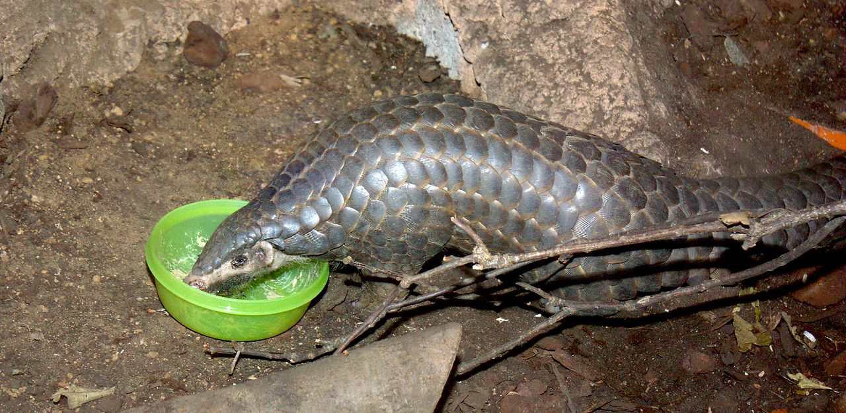

A Chinese pangolin

Though pangolins are protected by an international ban on their trade, populations have suffered from illegal trafficking due to unfounded beliefs in East Asia that their ground-up scales can stimulate lactation or cure cancer or asthma [39]. In the past decade, numerous seizures of illegally trafficked pangolin and pangolin meat have taken place in Asia [40] [41] [42] [43]. In one such incident in April 2013, 10 000 kg of pangolin meat were seized from a Chinese vessel that ran aground in the Philippines [44] [45]. In another case in August 2016, an Indonesian man was arrested after police raided his home and found over 650 pangolins in freezers on his property [46]. The same threat is reported in many countries in Africa, especially Nigeria, where the animal is on the verge of extinction due to overexploitation [47].

As a result of increasing threats to pangolins, mainly in the form of illegal, international trade in pangolin skin, scales, and meat, these species have received increasing conservation attention in recent years. For example, in 2014, the IUCN recategorised all eight species of pangolin on its Red List of Threatened Species, and each species is now properly listed as being threatened with extinction [48]. Also, the IUCN SSC Pangolin Specialist Group launched a global action plan to conserve pangolins, dubbed "Scaling up Pangolin Conservation" in July 2014. This action plan aims to improve all aspects of pangolin conservation with an added emphasis on combating poaching and trafficking of the animal, while educating communities in its importance [34]. Another suggested approach to fighting pangolin (and general wildlife) trafficking consists in "following the money" rather than "the animal", which aims to disrupt smugglers' profits by interrupting money flows. Financial intelligence gathering could thus become a key tool in protecting these animals, although this opportunity is often overlooked [33].

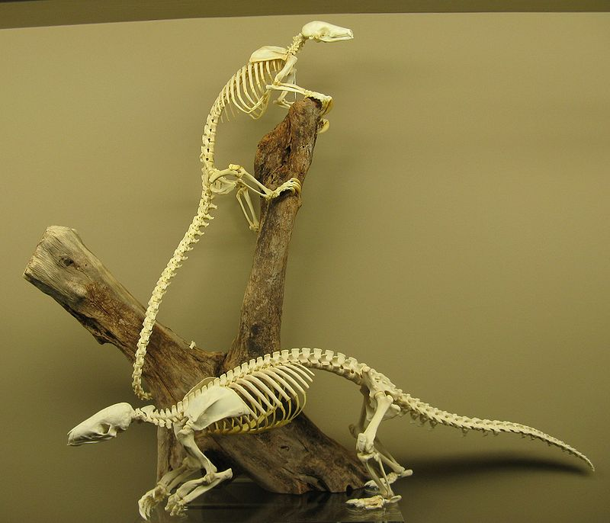

Pangolin skeletons

Many attempts have been made to reproduce pangolins in captivity, but due to their reliance on wide-ranging habitats and very particular diets, these attempts are often unsuccessful [26]. They are susceptible to diseases such as pneumonia and the development of ulcers in captivity, complications which can lead to an early death [26]. In addition, pangolins rescued from illegal trade often have a higher chance of being infected with parasites such as intestinal worms, further lessening their chance for rehabilitation and reintroduction to the wild [26]. Recently, researchers have been able to improve artificial pangolin habitats to allow for reproduction of pangolins, providing some hope for future reintroduction of these species into their natural habitats [9].

The third Saturday in February is promoted as World Pangolin Day by the conservation NPO Annamiticus [49].

###### References

1. Wikisource Thomas, Oldfield; Lydekker, Richard (1911). "Pangolin". Encyclopædia Britannica (11th ed.).
2. Gaudin, Timothy (28 August 2009). "The Phylogeny of Living and Extinct Pangolins (Mammalia, Pholidota) and Associated Taxa: A Morphology Based Analysis" (PDF). Journal of Mammalian Evolution. 16 (4): 235–305. doi:10.1007/s10914-009-9119-9. Retrieved 14 May 2015.
3. Goode, Emilia (31 March 2015). "A Struggle to Save the Scaly Pangolin". The New York Times. Retrieved 1 May 2016.
4. "Search result for "Pangolin"". IUCN Red List of Threatened Species. Retrieved 12 January 2016.
5. Judy Pearsall, ed. (2002). Concise Oxford English Dictionary (10th ed.). Oxford University Press. p. 1030. ISBN 0-19-860572-2.
6. "ITIS Report Manis Linnaeus, 1758". Retrieved 2018-05-28.
7. "S2A3 Biographical Database of Southern African Science [Johannes Smuts]". Retrieved 2018-05-28.
8. Palmer, T.S. (1904). "Index Generum Mammalium: a List of the Genera and Families of Mammals". North American Fauna. 23: 635. Retrieved 2018-05-28.
9. Yu, Jingyu; Jiang, Fulin; Peng, Jianjun; Yin, Xilin; Ma, Xiaohua (Oct 2015). "The First Birth and Survival of Cub in Captivity of Critically Endangered Malayan Pangolin (Mariis javanica)". Agricultural Science & Technology. 16 (10) – via EBSCO.
10. Spearman, R.I.C. (2008). "On the nature of the horny scales of the pangolin". Zoological Journal of the Linnean Society. 46 (310): 267–273. doi:10.1111/j.1096-3642.1967.tb00508.x.
11. Wang, Bin (2016). "Pangolin armor: Overlapping, structure, and mechanical properties of the keratinous scales". Acta Biomaterialia. 41: 60–74. doi:10.1016/j.actbio.2016.05.028. PMID 27221793.
12. "Meet the Pangolin!". Pangolins.org. 2015. Archived from the original on 2015-02-22.
13. "Manis tricuspis tree pangolin". University of Michigan. 2014. Archived from the original on 2015-02-22.
14. Chan, Lap-Ki (1995). "Extrinsic Lingual Musculature of Two Pangolins (Pholidota: Manidae)". Journal of Mammalogy. American Society of Mammalogists. 76 (2): 472–480. doi:10.2307/1382356. JSTOR 1382356.
15. Mondadori, Arnoldo, ed. (1988). Great Book of the Animal Kingdom. New York: Arch Cape Press. p. 252. ISBN 978-0517667910.
16. Bromley, Victoria (Director/Producer), Young, Nora (Narrator/Host), Diekmann, Maria (2018). Nature: The World's Most Wanted Animal. United States: PBS.
17. Mohapatra, R.K.; Panda, S. (2014). "Behavioural descriptions of Indian pangolins (Manis crassicaudata) in captivity". International Journal of Zoology. 2014: 1–7. doi:10.1155/2014/795062.
18. Grosshuesch, Craig (2012). "Rollin' With the Pangolin - Diet". University of Wisconsin–La Crosse. Archived from the original on 22 February 2015.
19. Rose, Kd; Gaudin, Tj (2001). eLS. John Wiley & Sons, Ltd. doi:10.1002/9780470015902.a0001556.pub2. ISBN 9780470015902.
20. Coulson, Ian M; Heath, Martha E (Dec 1997). "Foraging behaviour and ecology of the Cape pangolin (Manis temminckii) in north-western Zimbabwe". African Journal of Ecology. 35 (4). doi:10.1111/j.1365-2028.1997.101-89101.x – via EBSCO.
21. Lee Gutteridge (2008). The South African Bushveld: A Field Guide from the Waterberg. 30° South Publishers. p. 36. ISBN 978-1-920143-13-8.
22. DK Publishing (6 October 2015). Wildlife of the World. DK Publishing. p. 215. ISBN 978-1-4654-4959-7.
23. Davit-Béal, Tiphaine; Tucker, Abigail S.; Sire, Jean-Yves (2009-04-01). "Loss of teeth and enamel in tetrapods: fossil record, genetic data and morphological adaptations". Journal of Anatomy. 214 (4): 477–501. doi:10.1111/j.1469-7580.2009.01060.x. ISSN 1469-7580. PMC 2736120.
24. Donald R. Prothero (15 November 2016). The Princeton Field Guide to Prehistoric Mammals. Princeton University Press. p. 118. ISBN 978-1-4008-8445-2.
25. Grosshuesch, Craig (2012). "Rollin' With the Pangolin - Reproduction". University of Wisconsin–La Crosse. Archived from the original on 22 February 2015.
26. Gong, Shiping; Hua, Liushuai; Wang, Fumin; Li, Weiye; Ge, Yan; Li, Xiaonan; Hou, Fanghui (2015-08-06). "Captive breeding of pangolins: current status, problems and future prospects". ZooKeys. 507: 99–114. doi:10.3897/zookeys.507.6970. ISSN 1313-2970. PMC 4490220. PMID 26155072.
27. Dickman, Christopher R. (1984). MacDonald, D., ed. The Encyclopedia of Mammals. New York: Facts on File. pp. 780–781. ISBN 0-87196-871-1.
28. Boakye, Maxwell Kwame; Pietersen, Darren William; Kotzé, Antoinette; Dalton, Desiré-Lee; Jansen, Raymond (2015-01-20). "Knowledge and uses of African pangolins as a source of traditional medicine in Ghana". PLOS ONE. 10 (1): e0117199. doi:10.1371/journal.pone.0117199. ISSN 1932-6203. PMC 4300090. PMID 25602281.
29. Hance, Jeremy (29 July 2014). "Over a million pangolins slaughtered in the last decade". Mongabay. Archived from the original on 8 December 2014. Retrieved 7 August 2014.
30. "Manis javanica". IUCN Red List. 2014. Archived from the original on 22 February 2015.
31. Actman, Jani (20 December 2015). "Crime Blotter: Pangolin Scales, Tiger Skins, and More". National Geographic. Retrieved 1 May 2016.
32. Cruise, Adam (18 April 2015). "Tiger Eyes, Crocodile Penis: It's What's For Dinner in Malaysia". National Geographic. Retrieved 1 May 2016.
33. Haenlein, Alexandria Reid, Cathy; Keatinge, Tom (2018-10-10). "What's the secret to saving this rare creature?". BBC News. Retrieved 2018-10-10.
34. "Action Plan". www.pangolinsg.org. Retrieved 2016-09-15.
35. Fletcher, Martin (2015-02-05). "The world's most-trafficked mammal - and the scaliest". BBC News. Retrieved 2018-10-10.
36. "Manis pentadactyla (Chinese Pangolin)". www.iucnredlist.org. Retrieved 2016-09-15.
37. Agence France-Presse (November 19, 2010). "'Asian unicorn' and scaly anteater make endangered list". The Sydney Morning Herald.
38. "Manis pentadactyla". IUCN Red List. 2014. Archived from the original on 9 February 2015.
39. Wassener, Bettina (12 March 2013). "No Species Is Safe From Burgeoning Wildlife Trade". The New York Times. Archived from the original on 22 February 2015.
40. Sutter, John D. (3 April 2014). "The Most Trafficked Mammal You've Never Heard Of". CNN. Archived from the original on 2 February 2015.
41. "23 tonnes of pangolins seized in a week". Traffic.org. 17 March 2008. Archived from the original on 26 November 2014.
42. Watts, Jonathan (25 May 2007). "'Noah's Ark' of 5,000 rare animals found floating off the coast of China". The Guardian. London. Archived from the original on 3 October 2014.
43. "Asia in Pictures". The Wall Street Journal. 27 May 2012. Archived from the original on 22 February 2015.
44. Carrington, Damian (15 April 2013). "Chinese vessel on Philippine coral reef caught with illegal pangolin meat". Associated Press. London. Archived from the original on 2013-04-17. Retrieved 16 April 2013.
45. Molland, Judy (16 April 2013). "Boat Filled With 22,000 Pounds Of Pangolin Hits Endangered Coral Reef". London: Care2. Archived from the original on 2013-04-17. Retrieved 17 April 2013.
46. "Indonesian man arrested as 650 pangolins found dead in freezers - BBC News". Retrieved 2016-08-27.
47. The Daily Trust (Nigeria), Saturday 18 February 2017
48. "The IUCN Red List of Threatened Species". iucnredlist.org. Retrieved 2015-10-17.
49. "World Pangolin Day - About". Pangolins.org/Annamiticus.
50. Murphy, Willian J., et al. (2001-12-14). "Resolution of the Early Placental Mammal Radiation Using Bayesian Phylogenetics". Science. 294 (5550): 2348–2351. doi:10.1126/science.1067179. PMID 11743200.
51. Beck, Robin MD; Bininda-Emonds, Olaf RP; Cardillo, Marcel; Liu, Fu-Guo; Purvis, Andy (2006). "A higher-level MRP supertree of placental mammals". BMC Evolutionary Biology. 6 (1): 93. doi:10.1186/1471-2148-6-93. PMC 1654192. PMID 17101039. Archived from the original on 9 October 2014.
52. For example, McKenna & Bell 1997, p. 222 in which they included palaeanodonts. (Rose 2006, p. 210)
53. Rook, D.L.; Hunter, J.P. (2013). "Rooting Around the Eutherian Family Tree: the Origin and Relations of the Taeniodonta". Journal of Mammalian Evolution. 21: 1–17. doi:10.1007/s10914-013-9230-9. Archived from the original on 22 February 2015. Retrieved May 23, 2018.
54. Halliday, Thomas J. D.; Upchurch, Paul; Goswami, Anjali (2015). "Resolving the relationships of Paleocene placental mammals". Biological Reviews: n/a–n/a. doi:10.1111/brv.12242. ISSN 1464-7931.
55. Kondrashov, Peter; Agadjanian, Alexandre K. (2012). "A nearly complete skeleton of Ernanodon (Mammalia, Palaeanodonta) from Mongolia: morphofunctional analysis". Journal of Vertebrate Paleontology. 32 (5): 983–1001. doi:10.1080/02724634.2012.694319. ISSN 0272-4634.
56. Haaramo, Mikko (2007). "Manidae– Recent pangolins". Mikko's Phylogeny Archive. Retrieved 23 May 2018.
57. "Taxonomic lists- Mammals". Paleofile.com. Retrieved 23 May 2018.
58. "Palaeanodonta". fossilworks.org. Paleobiology Database. Retrieved 13 March 2017.