**TABLE OF CONTENTS:**

GOLD: A RESOURCE 2

Resources and power 2

Middle Ages 2

Gold as an Element – now 4

YEAR-ON-YEAR FLUCTUATIONS 6

Year-on-year percentage change in the volume of mining production 6

Table of Figures: 6

*Adapted from Matthew Hart's latest book, 'Gold: the Race for the World's Most Seductive Metal', published by Simon & Schuster*

*Adapted from http://www.telegraph.co.uk.html*

# GOLD: A RESOURCE

## Resources and power

South Africa is rich in a variety of minerals.

Except for diamonds and gold, the country also has resources of iron ore, platinum, manganese, chromium, copper, uranium, silver, beryllium, and titanium. No commercial petroleum have been found, but there are fair amounts of natural gas located off the southern coast, and synthetic fuel is made from coal at two large plants in the provinces of Free State and Mpumalanga.

Although for decades manufacturing has employed more people and produced a greater proportion of gross domestic product (GDP) than mining has, the mining sector continues to form the core of the South African economy as mining companies invest in other economic activity. Gold remains the most important mineral—South Africa is the world's largest producer—and reserves are large; however, (see production is slowly declining), prices have never equalled their spectacular highs of the early 1970s. As a result, a number of older mines have been rendered marginal or unprofitable. Several gold mines closed in the 1990s, and thousands of mine workers lost their jobs. The main goldfields centred historically on Johannesburg; the major areas of production now lie some distance east, west (Far West Rand), and south (northern Free State) of Johannesburg, centred on the areas of Klerksdorp and Evander.

Insert text

### Middle Ages

Scroll ahead to the middle Ages. Europe's biggest gold supplier was a near-mythical African ruler called Mansa Musa. He reigned over the gold-rich Mali Empire, a surprisingly urban civilisation along the Niger River. Mansa Musa built mosques and palaces in cities such as Timbuktu and Djenné. In the imperial capital, Niani, he received tributaries in an audience hall with windows framed in beaten gold.

Sometimes called the Lord of the Mines, Mansa Musa glittered in the European imagination. The Catalan Atlas of 1380 depicts him enthroned in the heart of Africa, a black king in gold regalia. In one raised hand he brandishes a fist-sized nugget.

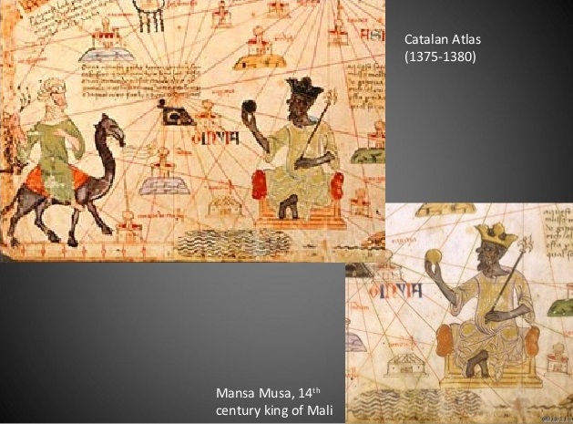

Figure 1: Mansa Musa

In 1324 this medieval master of gold made his hajj – the pious Muslim's pilgrimage to Mecca. Arab historians record that his retinue numbered 60,000 soldiers and 12,000 slaves. An 80-camel train plodded through the desert under a huge burden of precious metal. As he passed through Cairo, the emperor's lavish alms poured so much bullion into the market that he crashed the gold price in the Mediterranean for a decade.

Yet at about this time, a decline in European gold-mine production was sparking a crisis in the Continental coin supply and, by the next century, explorers were ranging far and wide to find new sources of gold. The Portuguese scoured the coast of Africa, looking for an entry point to Mansa Musa's empire. Meanwhile, the Spaniards sailed west, on what became the world's first gold rush – a campaign of conquest so sanguinary and grotesque that it beggars the imagination.

With the 16th-century's weapon of mass destruction (Toledo steel), a handful of Spaniards butchered their way through Bronze Age armies, laying in the dust two of history's most enchanting civilisations: the Aztec and the Inca.

Picture the Inca god-king, Atahualpa, seated on a throne of solid gold. A gold-and-emerald necklace gleams on his chest and gold braid glitters in his hair. On his forehead is the Inca's scarlet tassel. Courtiers in chequered livery sweep the ground before him. Eighty nobles in blue robes carry his silver litter into the little square at Cajamarca, in the Peruvian Andes, to meet Francisco Pizarro. Eight thousand men under arms accompany the Inca. The rest of his army – 70 000 soldiers hardened by the battles of a civil war – are camped no more than a mile or two away.

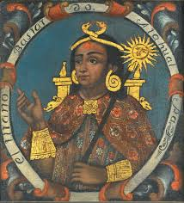

Figure 2: Atahualpa

Yet when the 168 Spaniards opened fire with hidden cannon, and unleashed their great swords, easily cutting through the copper armour of the native troops, it might as well have been a column of tanks that burst upon the Inca. Before they garrotted Atahualpa, the Spaniards forced from his people a ransom. Along the royal road from Cuzco, the Inca capital, came gold cups and vases and delicate golden statuettes of llamas, gold birds and trees, and a device like a fountain spewing gold. A solid-gold sacrificial altar weighed half a ton; the golden fountain, 700 lb.

A few choice objects were sent to the Spanish court; the rest was melted. The Spaniards shovelled every ounce straight into their furnace at Cajamarca, with the king's notary jotting down the weights as it went in. The booty weighed five tons, not including Atahualpa's 190 lb. throne. But in a twinkling they transformed the ravishing artefacts of a culture into what gold meant to them: cash. In one month alone the Spanish netted 1,326,539 gold pesos, or about £200 million in today's money. That's why museums have so little Inca gold: the Spaniards swallowed the lot. Who knows? Buy one of the Mint's pocket‑sized bullion lumps and you may be getting all that remains of some tiny golden llama.

### Gold as an Element – now

As an element, gold is undeniable: it will not tarnish or corrode. Dug out of the ground after centuries, its lustre is as fresh as a newly minted coin. And in the 500 years since Atahualpa's demise, gold has lost none of its allure in the West. It has shone brightly in the minds of our economists, with many countries backing their currencies with gold, in a form of financial governance called the gold standard.

As it existed immediately after the Second World War, when the United States owned 70 per cent of the world's monetary gold, the "gold standard" described a system in which many currencies were pegged to the US dollar, and the dollar alone was convertible to gold. Under that system, holders of large dollar deposits could convert them to gold at an established rate – R35 an ounce.

It was a regime that lasted until Richard Nixon came to office, when America's trade deficit was growing by the day, as Americans bought foreign goods but foreigners declined to buy American. Not needing US dollars, foreign central banks began to cash them in. Bullion flooded out of the US Treasury's repository at Fort Knox, Kentucky, and off to the vaults of other nations. Like a headstrong child who doesn't like the way the game is going, Nixon changed the rules, and on live television one Sunday night in August 1971, he ended the gold convertibility of the dollar. From that Sunday forth, the paper you held was all you were going to get. Those who wait for the gold standard's return cherish a threadbare hope. As money, gold is dead for good.

Cut loose from government control, the gold price was free to find its own level. Traders call gold the "emotive metal", and since then the emotion often driving it has been fear. That's what happened in the 2008 banking crisis. Frightened by disintegrating currencies, investors set the gold price on a trajectory that did not peak until it brushed R1 900 an ounce. Now, after a long decline, the gold price is stirring again, and gold bugs smell another run. Perhaps stashing a few of the Mint's new bars under your pillow isn't such a bad idea after all.

# YEAR-ON-YEAR FLUCTUATIONS

## Year-on-year percentage change in the volume of mining production

Table : Year-on-year changes

|  |  |  |  |  |  |  |
| --- | --- | --- | --- | --- | --- | --- |
| **Year** | **2010** | **2011** | **2012** | **2013** | **2014** | **Lowest** |
|  | 4.8 | -0.9 | -3.1 | 3.6 | -1.6 | 0 |

**Breakdown per month:**

Month, 2011, 2012, 2013, 2014, 2015

|  |  |  |  |  |  |
| --- | --- | --- | --- | --- | --- |
| Jan | 9.1 | 0.2 | -2.9 | 7.0 | 1.6 |
| Feb | 6.7 | 2.4 | -8.0 | 6.3 | -3.1 |
| Mar | 11.0 | -0.6 | -5.6 | -3.6 | -1.5 |
| Apr | 0.5 | 11.2 | -9.5 | 1.3 | 1.5 |
| May | -6.7 | 8.9 | 3.0 | -0.9 | -3.7 |
| Jun | 0.9 | -0.6 | 4.8 | -4.3 | -4.0 |
| Jul | -0.5 | -5.0 | 7.5 | 1.6 | -5.2 |
| Aug | 8.8 | -4.6 | 1.8 | 1.5 | -7.2 |
| Sep | 9.7 | -3.1 | -6.9 | 0.0 | 6.0 |
| Oct | 5.0 | -10.0 | -9.1 | 24.3 | -0.4 |
| Nov | 7.7 | -4.1 | -4.4 | 5.9 | -0.2 |
| Dec | 7.7 | -1.3 | -9.2 | 10.0 | -3.0 |



Gold price predictions

# Table of Figures:

Figure 1: Mansa Musa 3

INDEX