|  |  |
| --- | --- |
| 10 Most Common Effects of Global Warming | Author  Enter Name and Surname here |

Adapted from: http://greenbuzzz.com/environment/10-most-common-effects-of-global-warming/

TABLE OF CONTENTS

One of the most controversial topics in today’s age is global warming 2

1. Rising Sea Levels 2

2. Heat Waves 3

3. Killer Storms 4

4. Drought 5

5. Species becoming extinct 6

7. Disappearing Glaciers 8

8. Wars 9

9. Economic Instability 10

10. Ecosystem Failure 11

# *One of the most controversial topics in today's age is global warming*

And it has far-reaching consequences for our entire planet. Global warming has been described as a long-term effect of the greenhouse gases that will affect our planet’s (Earth) temperature as they build up in the atmosphere. Even though ****global warming****’s a topic for debate in the scientific as well as political community the ramifications are being felt already all across the world. We might not yet be in agreement on the causes; however the global warming effects threaten to not only be widespread, but also catastrophic.

# 1. Rising Sea Levels

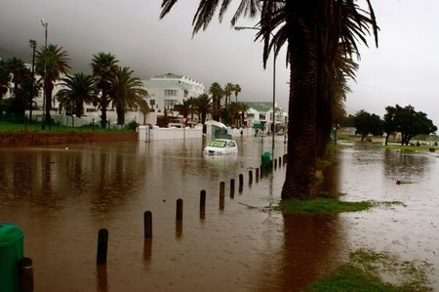

When the surface temperature warms up, it causes a significant melting of ice from the glaciers, sea ice as well as the polar ice shelf. When this happens, it increases the quantity of water that flows into oceans all around the world & leads to sea levels rising dramatically, threatening numerous population centers which are positioned in the low-lying coastal areas.

# Heat Waves

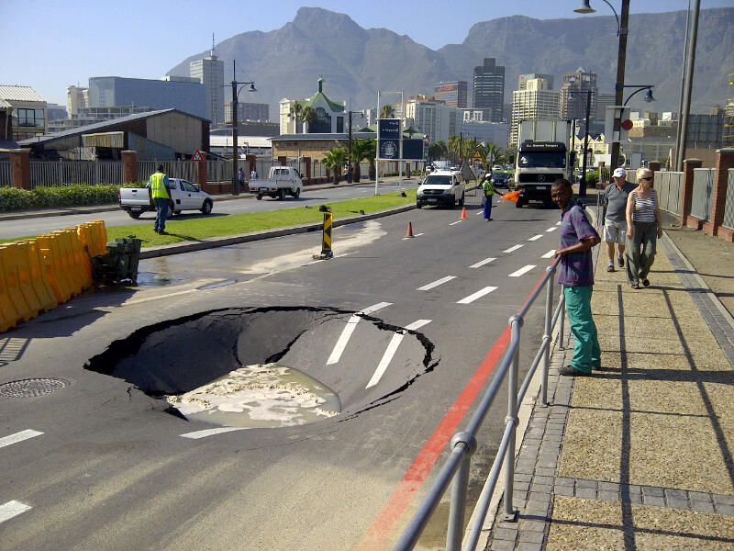

Severe heat waves have become more common and the reason is that the greenhouse gases have been trapped inside the atmosphere. Studies state that these heat waves will keep on increasing over the years & become 100 times worse. This will result in a swell in illnesses that are heat-related and also trigger countless wildfires.

# Killer Storms

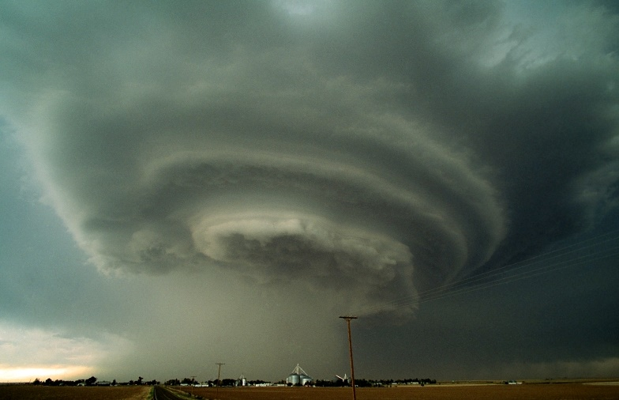

One of the deadliest effects of global warming are killer storms. When the temperature of the oceans becomes warmer, it fuels storms that are more intense. Global warming shall cause storms to become extremely severe and the numbers will increase as well. The warm ocean water will fuel storm intensity & result in greater number of extremely devastating hurricanes. Effects such as these are being felt already today – we have seen that in the last 30 years, the severity & number of cyclones, hurricanes and storms have increased and they have nearly doubled. All this leads to floods, damage of property as well as loss of life.

# Drought

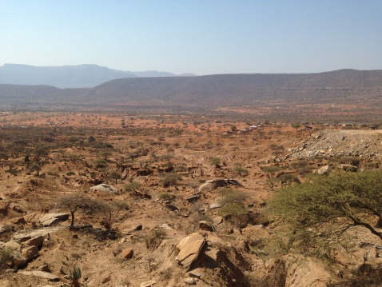

Droughts are on the opposite pole of this spectrum & we can see that they are already creating havoc on various parts of our planet. The climate is warming up & in turn dwindling the supply of water, leading to poor agricultural conditions. Because of this, crops are failing increasingly. There is a major shortage of water which is causing disruptions in the global production of food & making starvation increasingly widespread.

# Species becoming extinct

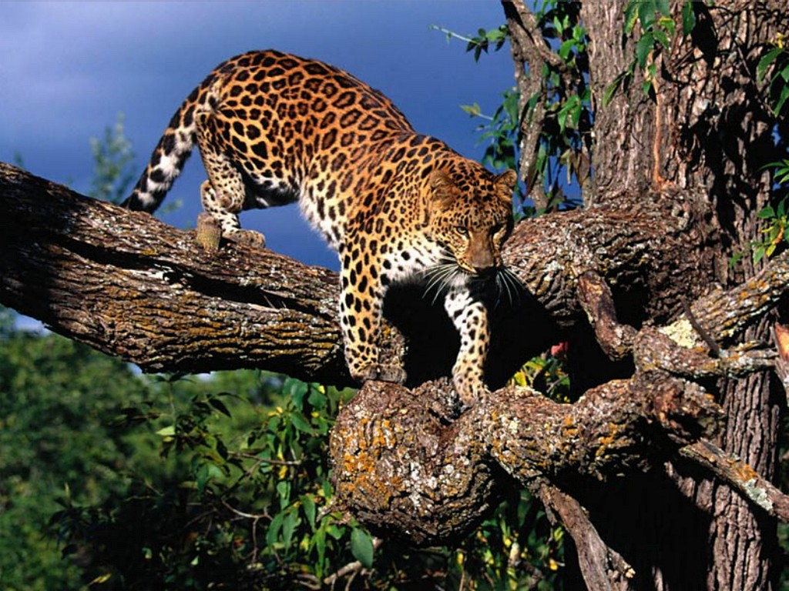

**Desertification, warming up of the ocean temperatures**, as well as deforestation is all contributing to disastrous & irreversible changes that are occurring in the habitat (plants & animals) & threatening to endanger several **species that might soon become extinct**. Polar bear happens to be the prime example and we see that their numbers are continuously falling as they struggle to acclimatize to loss in ice in regions in arctic. One thing that is crucial for human success is biodiversity & the loss of precious flora & fauna because of mass extinction will threaten our entire planet.

|  |  |  |  |  |  |  |
| --- | --- | --- | --- | --- | --- | --- |
| Item | Mammals | Birds | Reptiles | Amphibians | Fishes | Plants |
| **Total listings** | **359** | **300** | **119** | **33** | **151** | **795** |
|  |  |  |  |  |  |  |
| **Endangered species, total** | **325** | **271** | **79** | **22** | **83** | **645** |
| Africa | 70 | 77 | 13 | 14 | 72 | 644 |
| Foreign | 255 | 194 | 66 | 8 | 11 | 1 |
|  |  |  |  |  |  |  |
| **Threatened species, total** | **34** | **29** | **40** | **11** | **68** | **150** |
| Africa | 14 | 16 | 24 | 10 | 67 | 148 |
| Foreign | 20 | 13 | 16 | 1 | 1 | 2 |

# Disease

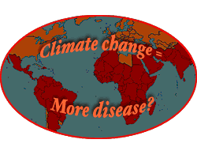

When there is a change in the habitat, it automatically translates to a rise in diseases all across the globe. Warmer temperatures, floods & droughts all combine & create a condition where rats, mosquitoes, as well as other pests that are disease-carrying not only thrive, but also adapt. Diseases such as cholera, West Nile virus, Lyme disease, dengue fever, etc. are ever increasing & are no longer limited to the tropical climates. It is seen that asthma is on a rise because of the increasing smog.

# Disappearing Glaciers

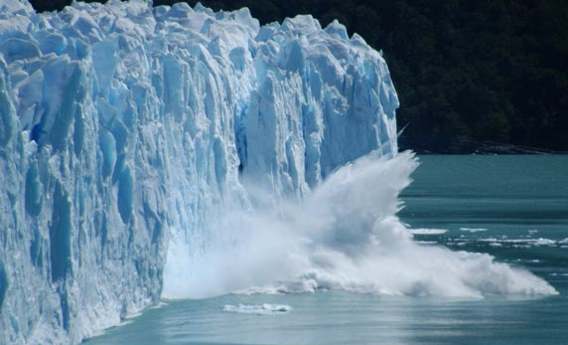

All across the globe we are seeing that glaciers are shrinking & that too at a very alarming rate. The Glacier National Park boasted 150 glaciers once upon a time, but now those numbers have dwindled to a mere 35 because of an alarming rise in the temperature. Elsewhere, the areas that were once covered in permafrost have now become home to numerous colorful plant life that is non-native.

# Wars

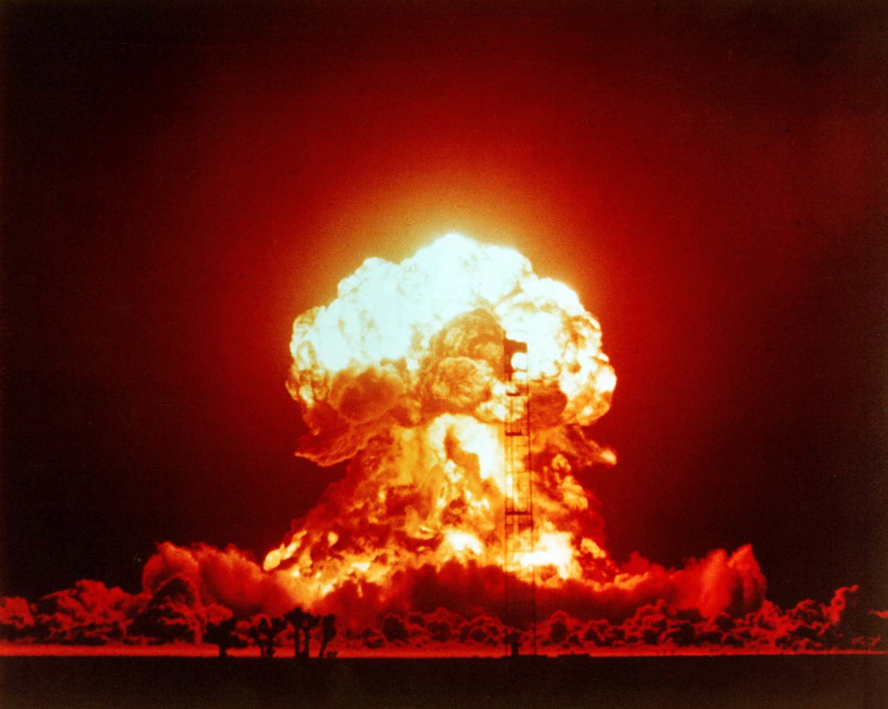

Worldwide conflicts & hostilities are on a rise as the numerous nations are competing for the resources that are dwindling. Not many of us are aware that the genocide that happened in Darfur region in Sudan was the consequence of ecological crisis that had roots in reduction of the natural resources that were brought about due to climatic changes. The wars in Somalia started under very similar circumstances. Today, experts dread that such increase in wars for water & food will result in hostility & aggression among some countries.

# Economic Instability



A nation’s economy is directly correlated to the consequences of climatic changes. Natural disasters like floods as well as hurricanes are costly, there are cleanup costs, and there is extensive damage to property, people lose their incomes and yet they try to reconstruct their lives. Global crisis is leading to a rise in the costs of energy & food; there are more costly insurance premiums, there’s loss of tourism dollars & industrial profits.

# Ecosystem Failure

## **Preventive Measures:**

**There are numerous ways in which we can prevent long-term effects of global warming.**

**A reduction in energy consumption is the simplest way to reduce these effects. Other precautionary measures include:**

**We should install light bulbs that are energy-efficient;**

**Always turn down the A/C & heaters;**

**Start using bicycles or start walking to work instead of buying more cars;**

**Unplug your phones & computer chargers whenever you are not using them.**

Index