**Webcams**

A webcam is a small digital video camera directly or indirectly connected to a computer or a computer network. Webcams come with software that needs to be installed on the computer to help users record video on or stream it from the Web. Webcams are capable of taking pictures as well as high-definition videos, although the video quality can be lower compared to other camera models. Webcams are also known as Web cameras.

A webcam is an input device that captures digital images. These are transferred to the computer, which moves them to a server. From there, they can be transmitted to the hosting page. Laptops and desktops are often equipped with a webcam.

Webcam characteristics include:

* Compared to other models of camera, webcams are considerably lower in cost, especially from a video telephony perspective.
* Compared to most handheld cameras, the maximum resolution of a webcam is low.
* The features of a webcam are largely dependent on the software operating system of the computer as well as the computer processor being used. Webcams can have additional features such as motion sensing, image archiving, automation or even custom coding.
* Webcams are mostly used in videoconferencing and for security surveillance. Other uses include video broadcasting, social video recording and computer vision.

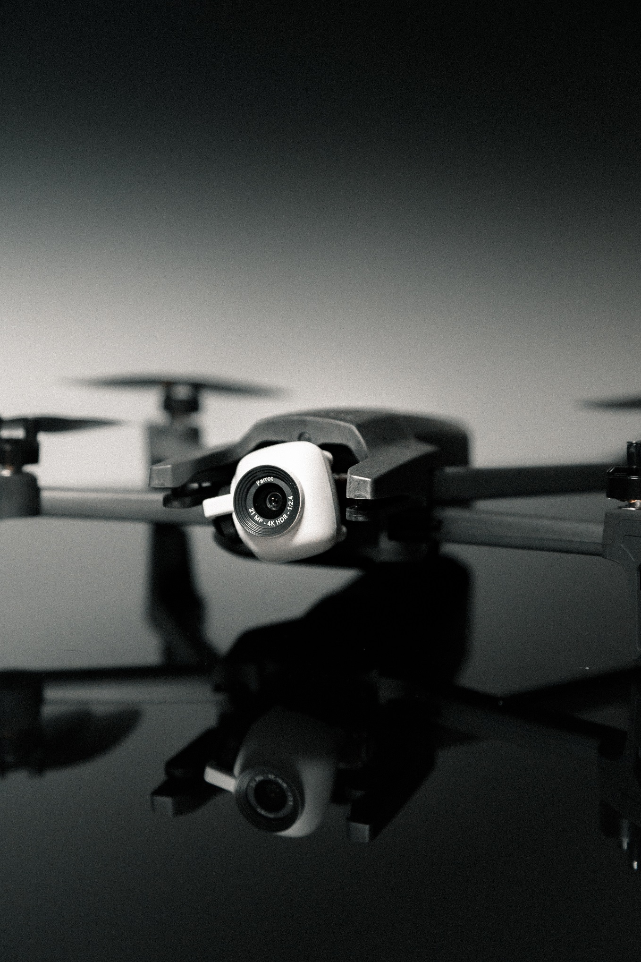 Photo by [Jakob Owens](https://unsplash.com/@jakobowens1?utm_source=unsplash&utm_medium=referral&utm_content=creditCopyText) on [Unsplash](https://unsplash.com/search/photos/webcam?utm_source=unsplash&utm_medium=referral&utm_content=creditCopyText)